ABSTRACT

Beginning with Benjamin Franklin's experiment with a kite, one stormy night in Philadelphia, the principles of electricity gradually evolved. In the mid-1800s, everyone's life changed with the invention of the electric light bulb. Thomas Edison improved the 1st electric bulb in 1879 and was able to produce a reliable, long-lasting source of light. Since then, providing electricity has become the basic means of living. This important facility is thus managed by the government established company A.P.S.E.B (Andhra Pradesh State Electricity Board).Population is increasing and new houses are being constructed, there by leading to new electrical connections. Manually maintaining the records is quite difficult and there comes the usage of computers, invented by “Charles Babbage” which has proved to be a boon in the current world. Starting with the “Analytical Engine”, much advancement has been done to the computer system. Now-a-days, computers are used everywhere. This usage of computers in A.P.S.E.B has reduced the work load, increased efficiency and reliability.

Our project basically deals with developing an application EBS (Energy Billing System). The Energy Billing System is an Executive Information System that could be used for entering, calculating and monitoring the Billing details of the Electricity Consumers. It provides environment to maintain the consumer details starting from getting new connection, receiving bill, payments etc., and performance information to the management.

It would be an Intranet and Internet based software solution that would ensure timely availability of status parameters. The ability to view the reports online ensures access to these reports from any machine on the ex-LAN and WAN network.

CHAPTER 1: INTRODUCTION

In today’s world of emerging technology, computers are playing a vital role in every walk of life. The problems due to the traditional system are overcome with the help of tasks being online. Maintenance of the data like insertion, deletion and modification is difficult with manual systems. The basic option of security is itself not provided which is of major concern. Apart from this, storage of the voluminous amounts of data is difficult. Moreover the problems of consistency, reliability, integrity also exists. Since this is a manual system there is always a probability that there is loss of data, resulting in less durability. As these issues are of major concern, we developed an application were in all the above factors are achieved.

To overcome the manual usage of data, A.P.S.E.B. used the concept of single tier architecture which could solve only few problems.

As these issues are of major concern, we developed an application to A.P.S.E.B. were in all the above factors are achieved. Addressing these issues, we develop a web application “EBS” (Electronic Billing System) which provides a service to all the customers and employees of A.P.S.E.B to deal with the transactions online.

Energy Billing System is an Executive Information System that could be used for entering, calculating and monitoring the Billing details of the Electricity Consumers. It provides environment to maintain the consumer details starting from getting new connection, receiving bill, payments etc., and performance information to the management.

It would be an Intranet and Internet based software solution that would ensure timely availability of status parameters. The ability to view the reports online ensure access to these reports from any machine on the ex LAN and WAN network.

The project basically deals with the billing system. Since it’s a web application the problems of single tier could be solved using this application. Customers can lodge a complaint or deal with new connections just by logging into the system.

The application basically starts by asking the user to sign in by choosing the CIRCLE ID and ERO ID. Later username and password of the employee option is provided. Validating the username and password, the user is directed to the homepage were in he has various options like consumer management, revenue collection, billing and accounting, generating the report. Regarding the modification, constraint is provided wherein the access is limited to the administrator. The statuses of the requests are updated at the earliest. The rectification information will be again updated for the knowledge of the employee. The employee can check the status of the requests before accessing the computer, which will speed up the disposal of the request. Thus, improving the overall efficiency of the organization.

The system captures data related to Consumers and presents them in the form of reports. These reports are meant for the ERO officers and top management to view details for track performance, generating D-List, were payments are not done. The System tracks the performance on a daily basis as well as cumulatively over a period of time. The System captures Information related to actual demand, energy using, payments, exceptions, and etc. from various levels of organization with in the aim of capturing it from as close to the source as possible.

The system helps the user to communicate with the administrator directly which is always expected for establishing a user-friendly environment. It can be used with existing software, so there is no need for any additional software. Thus, making it technically feasible.

  - Scope
This application is basically written as a solution to the drawbacks of existing system. This application can be used as a real world application and by any organization. It’s could be used as a general application with few minor modifications.

  - Purpose
The purpose of this application is to develop “EBS” (Electronic Billing System), which is a web application which provides a service to all the customers and employees of A.P.S.E.B to deal with the transactions online.

The company is presently dealing with the transactions using Oracle. The problem with D2K is that there exists heavy network traffic either in two tier or three tier architecture. Here the cost to develop the project will be less but the reliability will be degraded. Thus this application provides a solution to problems of single tier. Customers can lodge a complaint or deal with new connections just by logging into the system and do the transactions online.

  - Problem & Existing technology
In the traditional system files were used to maintain the database which was done manually. This existing system consumes a lot of time. This time consuming evaluation coupled by the huge maintenance problem and may also lead to erroneous results. The various operations performed on these files like sorting, adding, modifying and deletion of the records are very tedious. Moreover these manually maintained files have the possibility of getting worn out. Thus, less durability is achieved.

Thus the demerits of the existing system can be summarized as follows…
- There is no consistency as the data may not be updated on time.
- Feasibility is reduced
- Less reliability
- Security is not provided and any one can access
- Prioritization of records is difficult.
- More erroneous
- Difficult to maintain
- As every thing is done manually its slow process
- No timely acknowledgement service

Taking the demerits into consideration, an alternative system which uses Oracle as both front end and back end was used. In front end, retrieval of the data from the database is done through SQL queries i.e using D2K forms. This is not a web application and the data is not distributed as only a single system is used. As it is confined only to a particular system, scope is limited and there is a hindrance to the reliability if the system fails.

The demerits of this alternate system are…
- Only single system used.
- If the system crashes then the data is lost
- too overburdened
- not reliable
- slow processing
- less flexible
- not so user friendly

1.4 Proposed system
The proposed system is developed based on the client server architecture, a request-response paradigm and is implemented with the help of advanced java using the tomcat web container. The employees can maintain and do the transactions online.

The application starts by asking for user name and password which provides authentication. This system provides high security where the unauthorized users cannot access the data.

Later we have different options for the employee like
- Consumer Management
- Revenue Collection
- Billing and Accounting
- Reports
- Meter Details
- Ledger Process
- Journal Details

The objectives of the proposed system are as follows:
- Easy to use, effective and efficient
- Accurate results.
- Easy maintenance.
- Fast access
- More feasibility
- More secure.
- Provides high consistency.
- More reliable

CHAPTER 2: REQUIREMENTS
2.1 Functional Requirements
In software engineering, a functional requirement defines a function of a software system or its component. A function is described as a set of inputs, the behavior, and outputs. Functional requirements may be calculations, technical details, data manipulation and processing and other specific functionality that show how a use case is to be fulfilled. They are supported by non-functional requirements, which impose constraints on the design or implementation (such as performance requirements, security, or reliability).As defined in requirements engineering, functional requirements specify particular behaviors of a system. This should be contrasted with non-functional requirements which specify overall characteristics such as cost and reliability.

2.1.2 Modules Description
2.1.2.1 Login

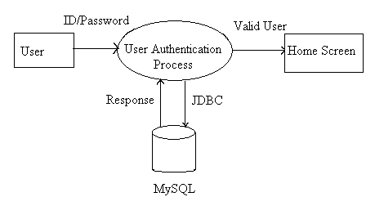
This module is considered only when there is a requirement of safety and security by the customer. Only after the login process, the rest of the application is made available to the user. In order to login, user has to first register by providing desired user-ID and password. Provided user-IDs and passwords by the users are maintained in a database. Oracle database is used to maintain a database. Then the user logins in to the application by giving user-ID and password provided during registration process. JDBC is used to connect the application with the database.
Oracle DDDDDDSDDDDDDDDB
User Login Sequence will be as follows:
- User registration by providing user-ID and password(credentials)
- User will be prompted to enter user credentials.
- If the user enters correct credentials then he gets access to the application.

      - Consumer Management
To design front-end forms according to consumer specifications it was like Addition of new consumer, deletion, modification of consumer, processing bills, journals, debit respectively. This module deals with consumer information details.

2.1.2.2.1 New Consumer Acquisition
The proposed software allows the end user to add the new consumer with his personal service (meter and Deposit) details. It generates a unique consumer Identification number based on the DISCOM, Circle, and division, Subdivision, Section and Distribution to which he belongs.

        - Modification of Consumer
If any particulars has modified with consumer details, this sub module is used to modify the consumer details.

        - Deletion of consumer
If any consumer disconnects the connection then we have to delete the consumer related information from system. This module is used to delete the consumer. Deletion is made is based on some rules like the payment details will be nil.

Message is displayed as do you want to delete the record. This deleting record is first entered into watch table. Then this record is deleted from Cons table, Bill, Meter part, deposit tab, calculator and PMTTAT tables.

2.1.2.2.4 Query Consumer
When ever we need to see the details of any particular consumer then this sub module will invoke the details and will display on the screen.

2.1.2.2.5 Meter Change
Every consumer is having meter for reading details. If meter will change then the meter details will be change in database. This sub module is used to update meter details.

2.1.2.2.6 Meter part Change
If any changes occurred in meter particulars then this sub module is used to update. The difference between Meter Change and Meter part Change is when ever Meter will change Meter Change sub module will use and Meter will not Change but Meter Characteristics will change then Meter part sub module will use.

      - Revenue Collection
Billing is done by spot billing machines and updated to billing database. This module deals with collection of payments through collection centers by online or offline each consumer wise.

2.1.2.3.1 Online Receipt
This sub module is user to online bill payment receipts. It will provide the entry fields to accept payments. It will show the consumer bill details and based on that we will know the bill details which were belongs to consumer whether consumer is having arrears or not. It is done on the spot when the consumer comes to pay bill. This is used by the persons, who know the RC (Revenue Collection) password.

2.1.2.3.2 Offline Receipt
This sub module is user to offline bill payment receipts. It is also same as online receipts, but it is used when consumers will pay the bill at general counters. It will show the consumer bill details and based on that we will know the bill details which were belongs to consumer whether consumer is having arrears or not. It is done after the consumer paid the bills offline. This is used by the persons, who know the RC (Revenue Collection) password.
2.1.2.3.3 Receipt Cancel
This sub module is allows the user to correct the mistakes done in using online receipt and offline receipt. It will provide the entry fields to cancel the payment receipts only. It will show the receipt details, which was done still by particular RC Counter. This is used by the persons, who know the RC (Revenue Collection) password.

2.1.2.4 Billing & Accounting
2.1.2.4.1 Journal Entry
Journal entry done when a consumer had any debit, credit amounts to pay .To that bill if any additional charges, electricity duty, interest on electricity duty levied on particular consumer no.

In this lccode should present in journal. If we enter consumer no corresponding name should be displayed and rest of the fields we should enter.
It should be updated to Journal.

2.1.2.4.2 Cancellation of Journal
If we want to cancel that particular person cancels any journal. It should check LC code, voucher number should match LC code, voucher date should match LC code, voucher no and then date field is selected. Then fields we are selected into corresponding text boxes. This journal is cancelled with field Jtcancelid=y. Now the field is cancelled from journal.

2.1.2.4.3 Change RC Password
Every ERO is having RC Counters to receive online payments. Each RC Counter is hiving RC Code and RC Password. This sub module is allows the user to change his Password for security purpose.

2.2 Nonfunctional Requirements
In systems engineering and requirements engineering, non-functional requirements are requirements which specify criteria that can be used to judge the operation of a system, rather than specific behaviors. This should be contrasted with functional requirements that specify specific behavior or functions. Non-functional requirements are often called qualities of a system. Other terms for non-functional requirements are "constraints", "quality attributes", "quality goals" and "quality of service requirements". Qualities, of Non-functional requirements can be divided into two main categories.

Execution qualities, such as security and usability, are observable at run time. Evolution qualities, such as extensibility and scalability, embody in the static structure of the software system.

2.2.1 Software Quality Attribute
2.2.1.1 Reliability: Reliability will mostly depend on the client's connection status. The reliability holds as long as clients are provided support to JDK 1.4 or later.

2.2.1.2 Availability: The server on which this system will be running is expected to be available at all hours of the day to provide worldwide accessibility. A graphical user interface (GUI) is provided to have online interaction with the user.

2.2.1.3 Maintainability: The business logic here is that there can be accounting feature in the future development of the product.. All development will be provided with good documentation.
2.2.1.4 Portability: As the system is designed using Java, it can work on any platform or architecture

2.2.2 Life cycle model used: Spiral model
In the proposed system the spiral model is used. The spiral model will give the benefit of adding the new features and if at all required it provides the necessity of doing changes in the design part to some extend, as there are quite number of enhancements are proposed on the system at later stage, hence the spiral model approach is being adopted for the system design and implementation.
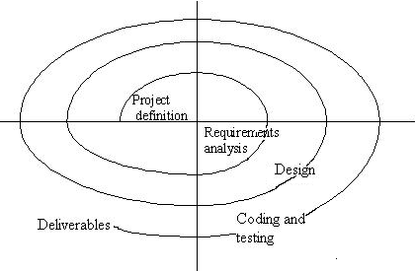
Fig 2.8: Spiral Model
Requirement analysis phase results in the specification of software’s operational characteristics; It allows software engineer to elaborate on basic requirements and build models that depict user scenarios. Software design is an iterative process through which requirements are translated into a “blue print” for constructing the software. It provides a complete picture of the software, addressing the data, functional and behavioral domains from an implementation perspective. The coding phase is the translation of the detailed design to the executable code using a programming language. In the coding phase, every module is identified and specified in the design document is independently coded and unit tested. Once the source code has been generated, software must be tested to uncover and correct as many errors as possible before deliver to the customer. Sequences of test cases are designed here.

2.2.3 Security requirements
Users are provided with a login page which contains a user-ID field and a password field. Users are requested to register before using the application. Then, the registered user is asked to provide the password and log-in user-ID in order to access the tool. This ensures security by allowing only authorized users.

2.3 Literature Survey
This project is developed in Java under Windows XP platform. In this modern world of computers, every noun in our vocabulary represents a class of objects sharing some set of characteristics and functional traits. Java leads itself naturally in embodying these areas into its own application domain.

2.3.1 HTML
HTML, an initialism of HyperText Markup Language, is the predominant markup language for web pages. It provides a means to describe the structure of text-based information in a document by denoting certain text as links, headings, paragraphs, lists, and so on and to supplement that text with interactive forms, embedded images, and other objects. HTML is written in the form of tags, surrounded by angle brackets. HTML can also describe, to some degree, the appearance and semantics of a document, and can include embedded scripting language code (such as JavaScript) which can affect the behavior of Web browsers and other HTML processors. Web pages are built with the help of this HTML which are called the Web Documents

2.3.2 Overview of Java
An Object Oriented Programming Language (OOPL) developed at Sun Microsystems. A Virtual Machine Run Time Environment that can be embedded in web browser (IE, NN). Java is a powerful but lean object oriented programming language. It has generated a lot of excitement because it makes it possible to program for Internet by creating applets, programs that can be embedded in web page.

Java is also being used more and more for writing standalone applications as well. It is becoming so popular that many people believe it will become standard language for both general purpose and Internet programming. There are many buzzwords associated with Java, but because of its spectacular growth in popularity, a new buzzword has appeared ubiquitous. Indeed, all indications are that it will soon be everywhere.

Java builds on the strength of C++. It has taken the best features of C++ and discarded the more problematic and error prone parts. To this lean core, it has added garbage collection (automatic memory management), multithreading (the capacity for one program to do more than one thing at a time), security capabilities. The result is simple, elegant, powerful and easy to use.
Java is actually a platform consisting of three components
- Java Programming Language.
- Java Library of Classes and Interfaces.
- Java Virtual Machine.
It also has a Standardized set of Packages (Class, Interfaces)
- Creating Graphical User Interfaces
- Controlling Multimedia Data
- Communicating over Network

2.3.3 Features of Java
Java is portable, object oriented, makes to write correct code, has Garbage collection, is Simple, it includes a library of classes and interfaces, is extensible, has Security, performs well, is robust, scales well, is multithreaded, is important to the internet. It has evolved a fantastic ability to generalize, classify and generate abstractions.
The essential aspects included in object-oriented approach
- Inheritance
- Polymorphism
- Platform Independence
- Robust
- Security
- Dynamic Binding

2.3.3.1. Inheritance
Inheritance is a sharing attribute and operation among classes based on hierarchical relationship. A class can be defined broadly and refined into successively five sub classes. Each sub class incorporates or inherits at the properties of its super class and adds its own unique properties. The ability to factor out common properties of several classes into a common super class and inherits the properties from the super class can greatly reduce repetition within designs and program is one of the main advantages of the object oriented analysis.

2.3.3.2 Polymorphism
Polymorphism means that the same operation may behave differently on different class. An operation is an action or transformation that an object performs or is subject to. A specific function in a class is called a METHOD. The language automatically selects the correct method to implement an operation based on the name of the operation and class the object operated on. New classes can be added without changing executing code provided methods are provided for each applications operation on the new classes.

2.3.3.3 Platform Independence
The Write-Once-Run-Anywhere ideal has not been achieved, but closer than with other languages. The java program written on one system can be run in any system with the help of the java virtual machine.

2.3.3.4 Robust
Exception handling built-in, strong type checking, local variables must be initialized. Thus the system is less error prone and more accurate results are obtained.

2.3.3.5 Security
- No memory pointers
- Programs run inside the virtual machine sandbox.
- Array index limit checking
- Code pathologies reduced by
- byte code verifier - checks classes after loading
- Class loader - confines objects to unique namespaces. Prevents loading a hacked "java.lang.SecurityManager" class, for example.
- security manager - determines what resources a class can access such as reading and writing to the local disk

2.3.3.6 Dynamic Binding
- The linking of data and methods to where they are located is done at run-time.
- New classes can be loaded while a program is running. Linking is done on the fly.
- Even if libraries are recompiled, there is no need to recompile code that uses classes in those libraries.
This differs from C++, which uses static binding. This can result in fragile classes for cases where linked code is changed and memory pointers then point to the wrong addresses.

WHY JAVA IS IMPORTANT TO THE INTERNET:

The Internet helped catapult java to the forefront of programming and java in turn has had profound effect on the Internet. The reason is simple. Java expands the universe of objects that can move about freely in cyberspace. In a network, there are two broad categorizes of objects transmitted between the server and your personal computer. Passive information and dynamic, active programs. For example when you read your email, you are viewing passive data. Even when you down load a program, the program’s code is still only passive data until execute it. However, there is a second type of object that can be transmitted to your computer: a dynamic, self-executing program. Such a program would be an active agent on the client computer, yet the server would initiate it.

2.3.4 Servlets
Java Servlet technology provides Web developers with a simple, consistent mechanism for extending the functionality of a Web server and for accessing existing business systems. A servlet can almost be thought of as an applet that runs on the server side--without a face. Java servlets make many Web applications possible

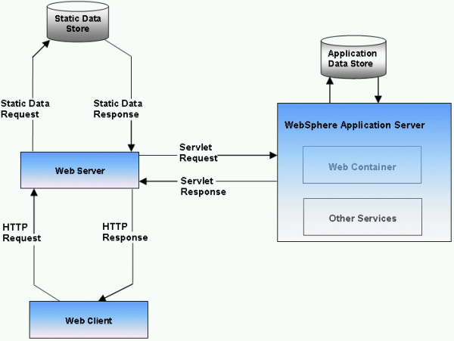
Fig 1: Servlet Architecture

A servlet is a Java programming language class used to extend the capabilities of servers that host applications accessed via a request-response programming model. Although servlets can respond to any type of request, they are commonly used to extend the applications hosted by Web servers. For such applications, Java Servlet technology defines HTTP-specific servlet classes.
The javax.servlet and javax.servlet.http packages provide interfaces and classes for writing servlets. All servlets must implement the Servlet interface, which defines life-cycle methods.

2.3.4.1 Servlet containers
A Servlet container is a specialized web server that supports Servlet execution. It combines the basic functionality of a web server with certain Java/Servlet specific optimizations and extensions – such as an integrated Java runtime environment, and the ability to automatically translate specific URLs into Servlet requests. Individual Servlets are registered with a Servlet container, providing the container with information about what functionality they provide, and what URL or other resource locator they will use to identify themselves. The Servlet container is then able to initialize the Servlet as necessary and deliver requests to the Servlet as they arrive. Many containers have the ability to dynamically add and remove Servlets from the system, allowing new Servlets to quickly be deployed or removed without affecting other Servlets running from the same container. Servlet containers are also referred to as web containers or web engines.

JAVA SERVER PAGES (JSP)

A JSP page is a text page document tat describes how to process request to create a response. JSP is a Java-based technology that simplifies the process of developing dynamic web sites. With JSP, web designers and developers can Quickly incorporate dynamic elements into web pages using embedded Java and simple mark-up tags. These tags provide the HTML designer with a way to access data and business logic stored inside Java object.

JSP are txt files with extension ‘.jsp’ which takes place of traditional HTML pages. JSP files contain traditional HTML along with the embedded Code that allows the developer to access data from the Java code running on the server.

Jsp is now an integral part of developing web-based application using java. Because of the ability to separate presentation from implementation logic by combing standard mark-up text with scripting element and object-oriented components, jsp provides an excellent front end technology for application that are the deployed over the web.

APPLICATION MODEL:

Jsp pages can be used in combination with servlets, http, html, xml, applets, java beans components and enterprise java beans components, to implement a word variety of application architecture(s)or models. To facilitate web-based applications, the, both servlets and jsp are required elements of j2ee specifications. And while both technologies can be used to dynamically generate html to be send to an end-users web browser, only jsp enforces a strong separation between presentation logic involved in displaying data and the business or programming logic used to generate data in first place. When
Using jsp, Changes to presentation of the data do not require any changes to the underlined server code that supplied data in the first place.

The java server pages technology offers the following advantages:

- Write once, run anywhere properties
- High quality tool support.
- Re-use of components and tag libraries.

Separation of dynamic and static content:
- Support for scripting and actions
- Web access layer for N-tier enterprise application architecture.

EXECUTING JSP:

Adding JSP support
The most basic requirements for using JSP are a web server implies. Both hardware in the form of a computer accessible over the Internet or a corporate based intranet and s/w in the form of an HTP server running on that hardware. Some of most popular http servers are: apache, Microsoft Internet information sever, web logic etc.

Jsp execution start with request for a jsp page the processing is done based on jsp tag on the page In order to generate contents dynamically and the output of the processing combined with the page static HTML, must be returned on the web browser.

SCRIPTING LANGUAGES:

The default scripting languages for JSP is, naturally, java. Since JSP Pages are compiled into java servlets, this assumption makes the translation of the scripts into sevlets code every straight forward. To be acceptable for use with JSP, scripting languages must meet three requirements:

- It must support the manipulation of Java objects.
- It must be include the ability to catch Java exceptions and specify exception handlers.
- It must be able to invoke methods on Java objects.

JSP Tags

JSP provides four major categories of markup tags. The first, directives, is a set of tags for providing the JSP container with page specific instructions for how the documents containing the directives are to be processed.
Secondly, scripting elements are used to embedded programming instructions written in the designated scripting language for the pages witch are to be executed each time.

The page is processed for request. Thirdly, comments are used for adding documentation strings to a JSP page. Fourthly, action support different behaviors.
<%=%> : USED FOR EXPRESSIONS
<%%> : USED FOR SCRIPLETS
<%!%> : USED FOR DECLARATION
<%@%> : USED FOR DIRECTIVES
<%@page%> : USED FOR PAGE DIRECTIVES.

EXPRESSIONS:

A JSP expression element is an scripting language expression that is evaluated and that can be converted into a string which is succeed emitted into the out object.
Syntax: <%= expression%>

SCRIPLET:
Scrip let can contain any code fragment that is valid for scripting language fragment.
Syntax: <%scrip let %>

DECLARATIONS:
These are used to declare variables and methods in the scripting language.
A declaration is initialized when the JSP page is initialized and is make available to other declarations and scrip lets.
Syntax: <%! Declarations%>

DIRECTIVES:
These are messages to JSP engine.
Syntax: <%@directives%>
PAGE DIRECTIVES:

The page directive defines a number of page dependent attributes and communicates these to the JSP engine.
Syntax: <%@page = directive-attribute-list%>
2.3.5 Tomcat
Apache Tomcat is an implementation of the Java Servlet and Java Server Pages technologies. The Java Servlet and Java Server Pages specifications are developed under the Process. Apache Tomcat is developed in an open and participatory environment and released under the Apache Software License. Apache Tomcat is intended to be a collaboration of the best-of-breed developers from around the world. We invite you to participate in this open development project Apache Tomcat powers numerous large-scale, mission-critical web applications across a diverse range of industries and organizations.

2.3.6 Java Database Connectivity
Java Database Connectivity (JDBC) is a back-end tool for connecting to a server to ODBC in that respect, However JDBC can connect only Java clients and it uses ODBC for the connectivity. JDBC is essentially a low-level application programming interface. It is called a low-level API since any data manipulation, storage and retrieval has to be done by the program itself. Some tools which provide a higher-level abstraction or expected shortly.

To use JDBC you need a basic knowledge of database and SQL. Apart from this you need the jdk1.1 (Java Development Kit 1.1) or a version of Java since jdk1.1 and above come bundled with JDBC software.

After that you need to have a back-end database engine for which a JDBC driver is available. When JDBC drivers are not available JDBC-ODBC bridge drivers are used to access the database through ODBC. Back-end is not need when JDBC driver is capable of storing and retrieving the data itself, or if JDBC-ODBC Bridge and the ODBC driver can be store and retrieve the information.

2.3.6.2 JDBC Driver Types
The JDBC drivers that we are aware of at this time fit into one of four categories:

2.3.6.2.1 JDBC-ODBC Bridge plus ODBC driver
The Java Soft bridge product provides JDBC access via ODBC drivers. Note that ODBC binary code and in many cases database client code must be loaded on each client machine that uses this driver. As a result, this kind of driver is most appropriate on a corporate network where client installations are not a major problem, or for application server code written in Java in three-tier architecture.

2.3.6.2.2 Native-API partly-Java driver
This kind of driver converts JDBC calls into calls on the client API for Oracle, Sybase, Informix, DB2, or other DBMS. Note that, like the bridge driver, this style of driver requires that some binary code be loaded on each client machine.

2.3.6.2.3 JDBC-Net all-Java driver
This driver translates JDBC calls into a DBMS-independent net protocol that is then translated to a DBMS protocol by server. This net server middle ware is able to connect its all-Java clients to many different databases. The specific protocol used depends on the vendor. In general, this is the most flexible JDBC alternative. It is likely that all vendors of this solution will provide products suitable for Internet use. In order for these products to also support Internet access, they must handle the additional requirements for security, access through firewalls, etc., that the Web imposes. Several vendors are adding JDBC drivers to their existing database middle ware products.

2.3.6.2.4 Native-protocol all-Java driver
This kind of driver converts JDBC calls into the network protocol used by DBMS directly. This allows a direct call from the client machine to the DBMS server and is a practical solution for Internet access.

2.3.6.2 Data Models
JDBC and accessing the database through applets, and JDBC API via an intermediate server resulted in a new type of database model which is different from the client-servers through which the request should go it is named as single tier, two tier and multi tier architecture.

2.3.6.3 Microsoft Access
Access is a database management system. Databases are an important part of everyday use. We use computers at home, in the fields of medicine, education, law, business, engineering and government. A database is a collection of data and facts that are related to a particular object or purpose, such as tracking customer orders or maintaining a music collection.

In Access, the heart of the database is the Table. One or more tables comprise a database. In addition to tables, a database can contain other objects such as queries, reports, forms and other components. These objects can be viewed and can manipulate the data contained in the database in variety of ways.

Database Objects | Description
Table | The primary units of a database that stores field names, field description, field controls and field data. Tables display multiple records in a row/column format similar to a spreadsheet layout.
Query | A structured guideline used to search database tables and retrieve records that meet specific conditions.
Table 2.4.5 Description of data base objects
2.4 Feasibility Analysis
The most successful system projects are not necessarily the biggest or most visible in a business but rather those that truly meet user expectations. More projects fail because of inflated expectations than for any other reason.
If the feasibility study is to serve as a decision document, it must answer three key questions:
- Is there a new and better way to do the job that will benefit the user?
- What are the costs and savings of the alternatives?
- What is recommended?

Three key considerations are involved in the feasibility analysis: economic, technical, and behavioral.

2.4.1 Economical feasibility
Economic analysis is the most frequently used method for evaluating the effectiveness of a candidate system. More commonly known as cost/benefit analysis, the procedure is to determine the benefits and savings that are expected from a candidate system and compare them with costs. If benefits outweigh costs, then the decision is made to design and implement the system. Otherwise, further justification or alterations in the proposed system will have to be made if it is to have a chance of being approved. This is an ongoing effort that improves in accuracy at each phase of the system life cycle.

2.4.2 Technical feasibility
Technical feasibility centers on the existing computer system (hardware, Software, etc.) and to what extent it can support the proposed addition. For example, if the current computer is operating at 80 percent capacity-an arbitrary ceiling-then running another application could overload the system or require additional hardware. This involves financial considerations to accommodate technical enhancements. If the budget is a serious constraint, then the project is judged not feasible.

2.4.3 Operational feasibility
Purpose projects are beneficial only if they can be turned into information systems that will meet the organization’s operating systems.
Some of the conditions are
Is there sufficient support for the project from management and users?
Are correct business methods acceptable to the users?
Have the users been involved in the planning and development of the project.
Will the proposed system cause harm?

2.5 System Requirements Specifications
2.5.1 Hardware Requirements
- Operating system : Any operating System
- Processor : PIII MHz or above
- RAM : 256 MB
- Hard Disk : Min 300 MB working space
- Key Board : 101 Standards

2.5.2 Software Requirements
- Languages : JDK1.5, Oracle
- Tools : Tomcat
- Technology : Java

CHAPTER 3: ARCHITECTURE
3.1 Technical Architecture
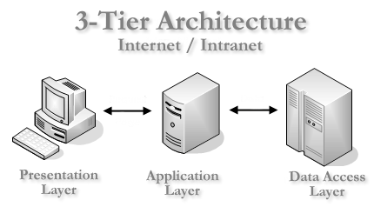
3.1.3 Three tier
Three-tier is a client-server architecture in which the user interface, functional process logic, computer data storage and data access are developed and maintained as independent modules, most often on separate platforms.
The 3-Tier architecture has the following three tiers:

3.1.3.1 Presentation Tier
This is the topmost level of the application. The presentation tier displays information related to such services as browsing merchandise, purchasing, and shopping cart contents. It communicates with other tiers by outputting results to the browser/client tier and all other tiers in the network.

3.1.3.2 Application Tier (Business Logic/Logic Tier)
The logic tier is pulled out from the presentation tier and, as its own layer, it controls an application’s functionality by performing detailed processing.
3.1.3.3 Data Tier
This tier consists of Database Servers. Here information is stored and retrieved. This tier keeps data neutral and independent from application servers or business logic. Giving data its own tier also improves scalability and performance.
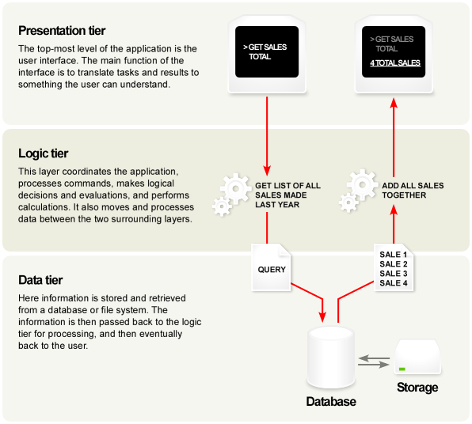
Fig 2.5.3: 3-tier Architecture

Chapter 4: DESIGN & IMPLEMENTATION
4.1 Flow chart
4.1.1 Homepage
Start
Read ERO no, Circle ID
Sign in
Read uname, pwd
Login
Consumer
Management
Revenue
Collection
Reports
Bill & account
Stop

4.1.2Consumer
Read Circle id, ERO id
Consumer Management
New User?
Modify
New Consumer
Delete Consumer?
Deletion of consumer
Query
Meter change?
Meter change
Stop
Meter Part change
Start
M_part change?
Management

4.1.3 Revenue
Collection
Read Circle id, ERO id
Revenue Collection
Stop
Start
Online Receipt
Offline Receipt
Receipt Collect

4.1.4 Billing &
Accounting
Read Circle id, ERO id
Billing & Accounting
Stop
Start
Journal entry
Journal entry cancel
RC pwd change

4.2 Data Flow Diagrams

A graphic tool used to describe and analyze the movement of data through a system – manual or automated –including the processes, stores of data, and delays in the system. Data flow diagrams are the central tool and the basis from which other components are developed. The transformation of data from input to output, through processes, may be described logically and independently of the physical components associated with the system. They are termed as logical data flow diagrams. in contrast, the physical data flow diagrams show the actual implementation and movement of data between people, departments ,and workstations.

4.2.1 Notations used in the DFD’s
We used three symbols from your don notation and from Gain& Sarsison notation as specified below.

DATA FLOW |  | Describes the data, flowing between processes, data stores and external entities
Process |  | Describes how input data is converted to output data.
Source or Sink |  | An external entity causing the origin of data.
Data Store |  | Describes the repositories of data in a system.

4.2.2 Types of dataflow diagrams
Data flow diagrams are of two types:
- Physical data flow diagrams
- An implementation –dependent view of the current system, showing what tasks are carried out and how they are performed.
- Physical characteristics include:
- Names of people
- Forms and document names or numbers
- Names of departments
- Master and transactions files
- Equipment and devices used
- Locations
- Names of procedures
- Logical Data Flow Diagrams
- An implementation –independent view of a system, focusing on the flow of data between processes without regard for the specific devices, storage locations, or the people in the system. Will not specify the physical characteristics listed above for physical data flow diagrams.

4.2.3 Drawing Physical Data Flow Diagrams
4.2.3.1 Drawing a Context Diagram:
The top-level diagram is often called a context diagram. It contains a single process, but it plays a very important role in studying the current system. The context diagram defines the system that will be studied in the sense that it determines the Boundaries. Anything that is not is part of the systems study.

4.2.3.2 Developing the first-level physical Data Flow Diagram
The description of a system in the context diagram requires more details. The next step is to describe the system, as we understand it at level 1 of the process hierarchy chart; i.e., we want to identify the data flows, data stores, inputs, and outputs that link together the processes.

4.2.3.3 Second level or exploding processes into greater detail
All activities, data flow, and data stores used in this lower level view of the system must be included within the previous data flow diagram. The lower-level view must be consistent with the higher –level view. However we continue to include the description of higher-level data flow diagrams. Because the nature and complexity of systems vary, it is unadvisable to fix a specific number of levels. In general, we should go as far as necessary to understand the details of the system and way it functions, taking care to verify all aspects with knowledge users.

4.2.4 Logical Data Flow Diagrams
Several rules are helpful in drawing useful logical data flow diagrams:
1. Any data flow leaving a process must be based on data that are input to the process.
2. All data flows are name; the names reflect the data flowing between processes,
And data stores, or sinks.
3. Only data needed to perform the process should be an input to the process.
4. A process should know nothing about, that is, be independent of, any other process in the system; it should depend only on its own input and output.
5. Processes are always running; they do not start or stop. Analysts should assume that a process is always ready to function or perform necessary work.
6. Output from processes can take one of the following forms:
- An input data flow with information added by the process
- A reason or change of data from
- Change a status. Change the content.

4.3 Unified Modeling Language
It is a language to specify, visualize and construct the artifacts of software system as well as for business models. GRADY BOOCH, IVAR JACCAOBSON and JAMES RUMBUGH found it. The UML notation is useful for graphically depicting Object Oriented Analysis and Object Oriented Design (OOA & OOD) modules.

4.3.1 Use Case Diagram
4.3.1.1 Homepage
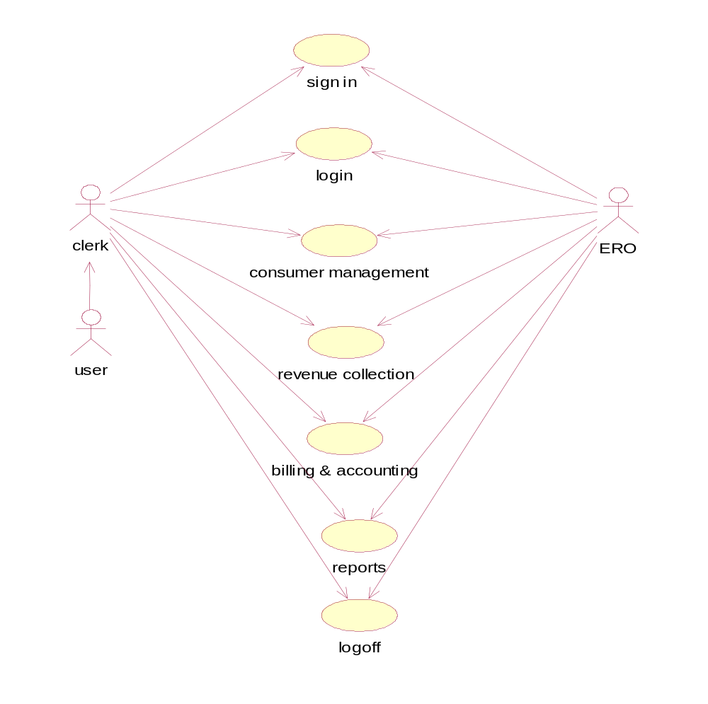
Fig 4.4.1.1: Use Case Diagram

4.3.1.2 Consumer Management
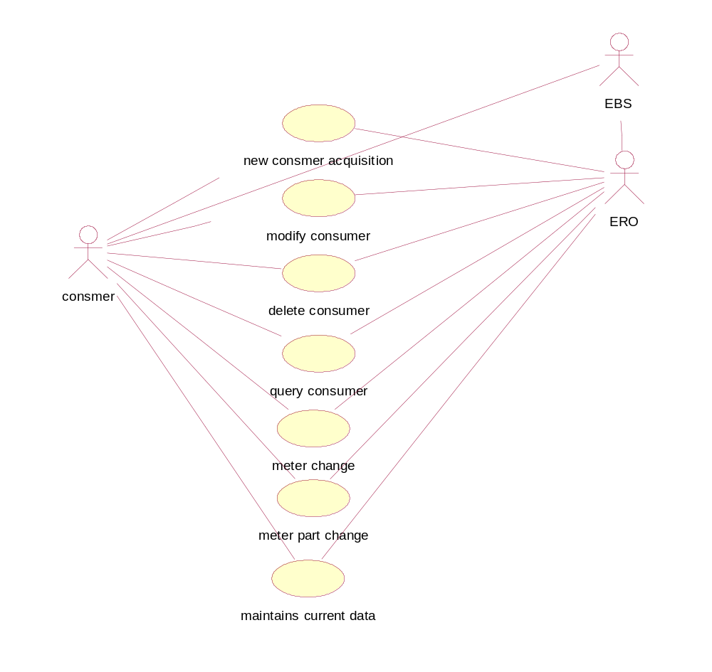
Fig 4.4.1.2: Consumer Management

4.3.1.3 Revenue Collection
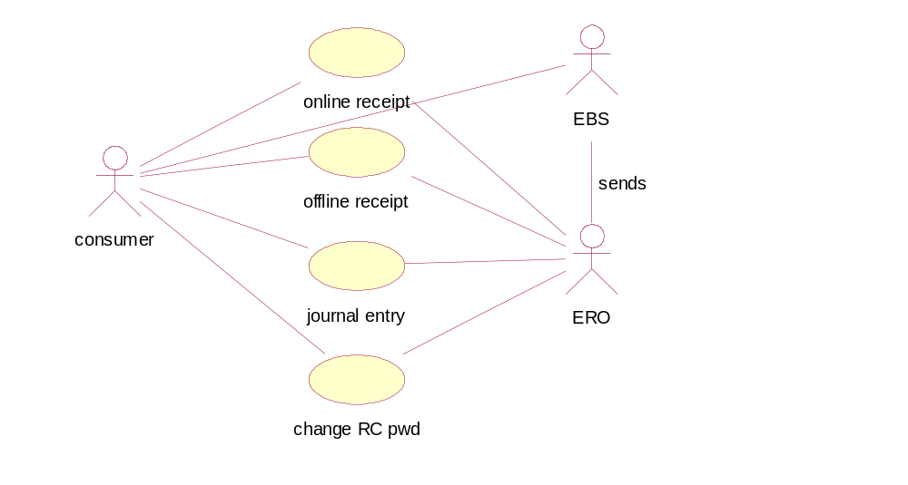
Fig 4.4.1.3: Revenue Collection

4.3.1.4 Billing & Accounting
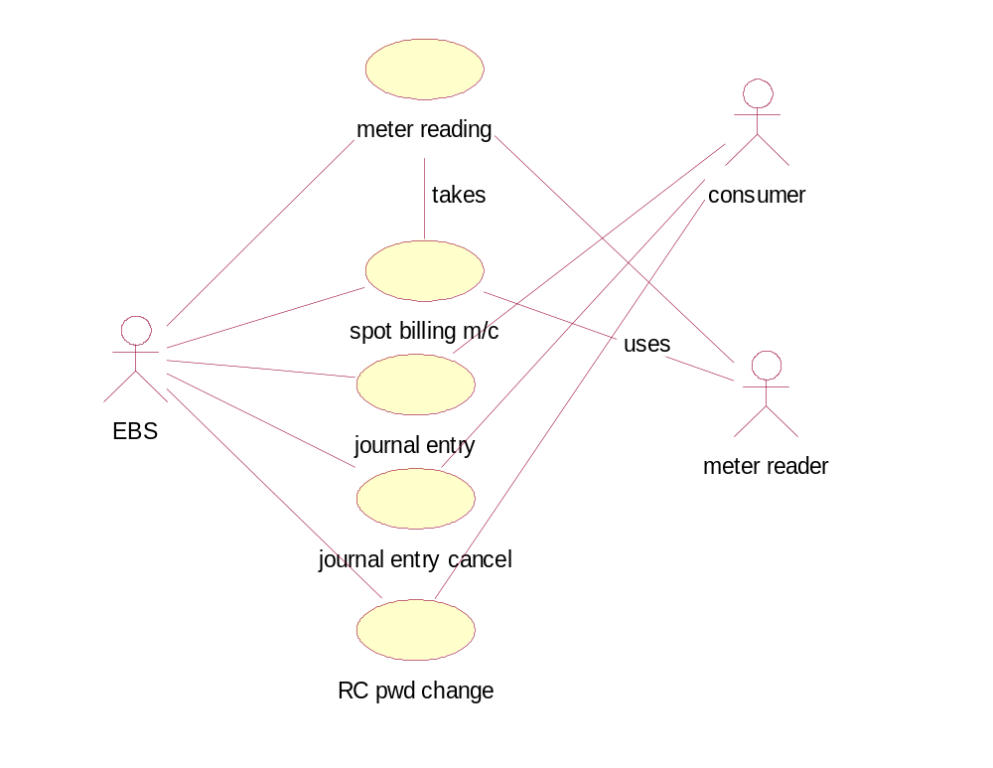
Fig 4.4.1.4: Billing & accounting
4.3.2 Class Diagram

4.3.2.1 EBS

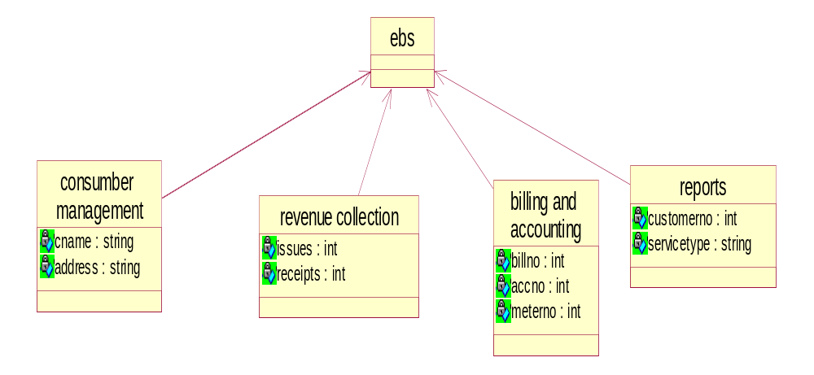

Fig 4.2.2.1: Class Diagram

4.3.2.2 Consumer Management
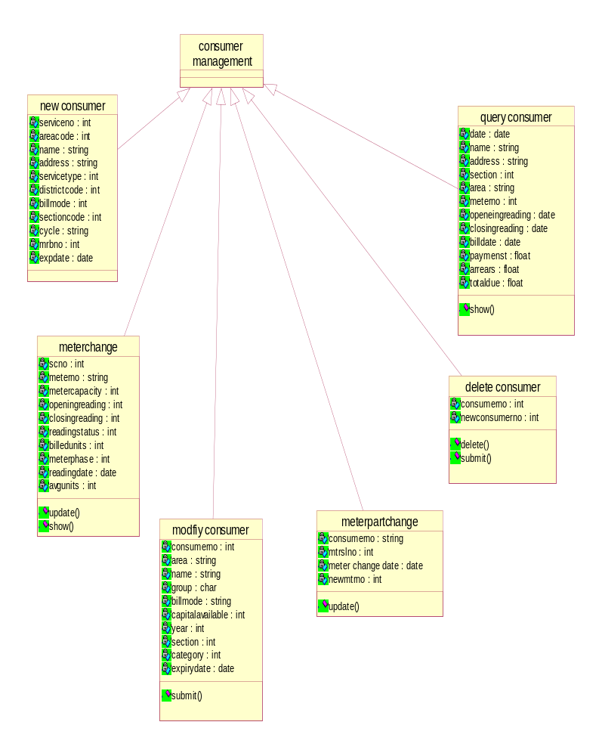

Fig 4.2.2.2: Class Diagram

4.3.2.3 Revenue Collection
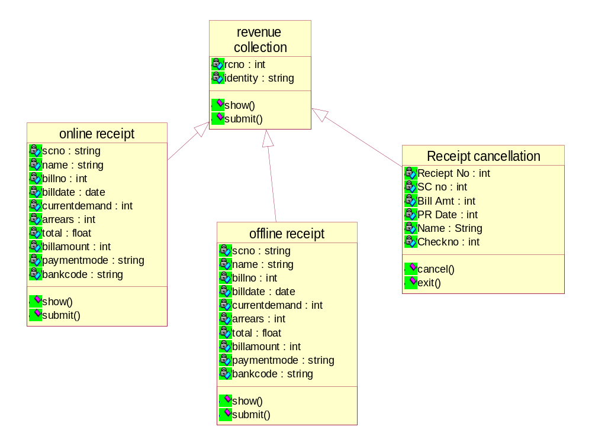
Fig 4.2.2.3: Class Diagram

4.3.2.4 Billing and Accounting

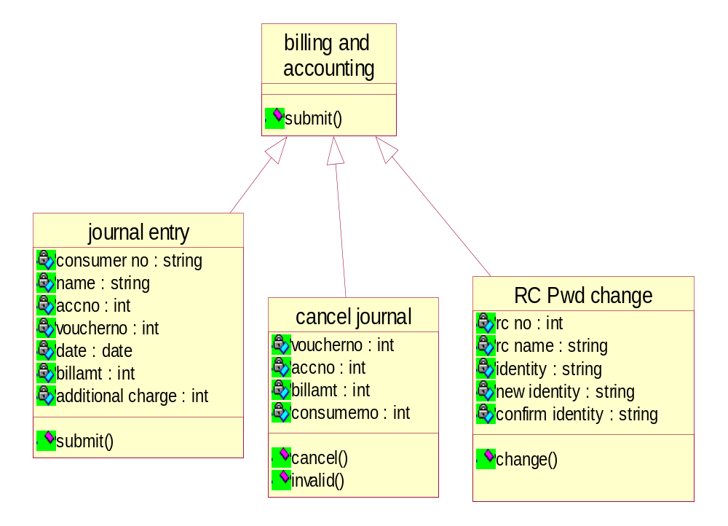

Fig 4.2.2.4: Class Diagram

4.3.3 Sequence Diagrams

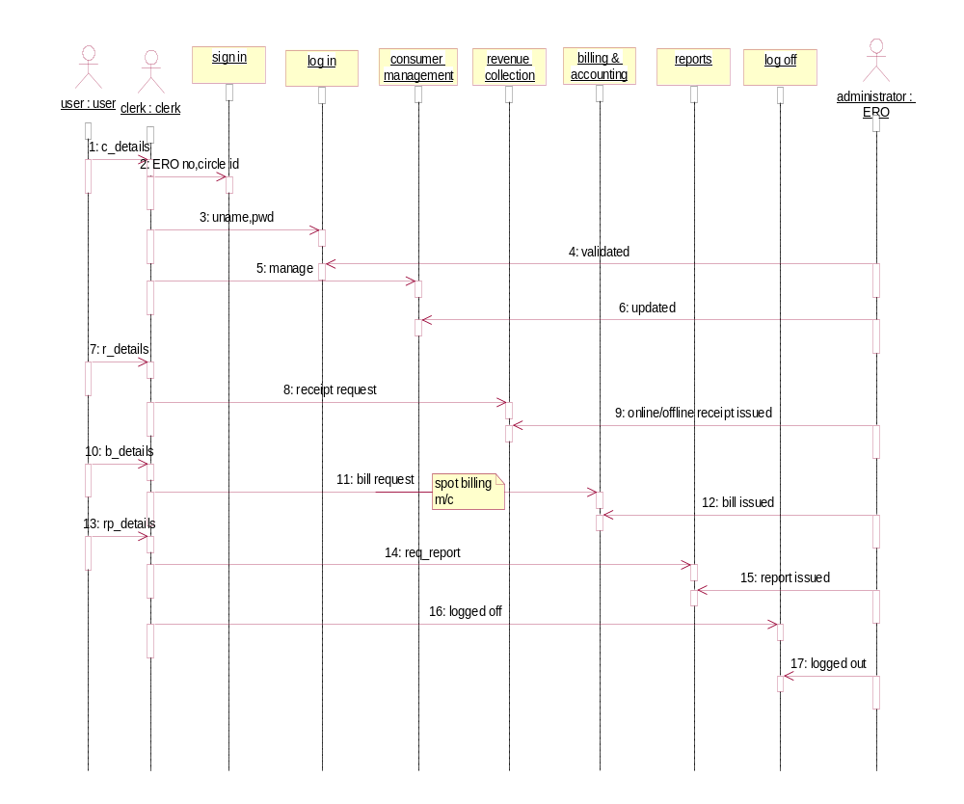

Fig 4.2.3 Sequence Diagram

4.3.4 Activity Diagram
4.3.4.1 Homepage

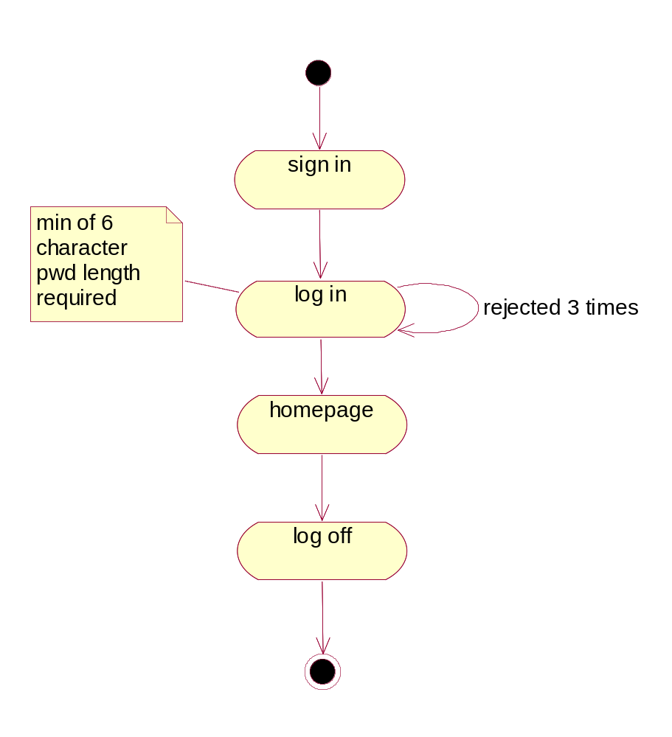
Fig 4.2.4.1: Activity Diagram

4.3.4.2 Consumer Management

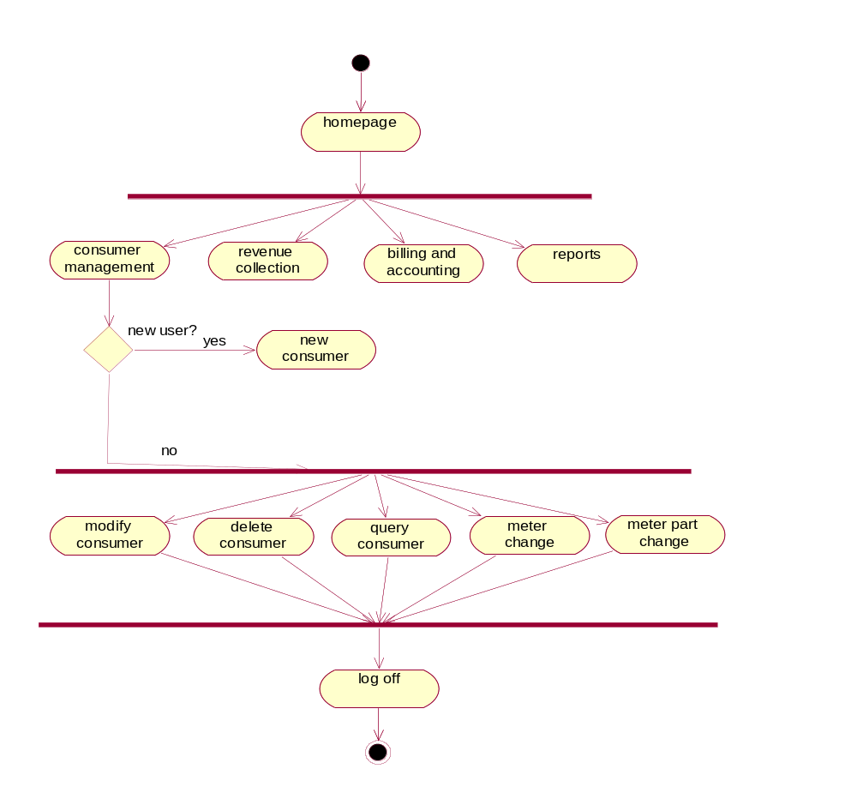
Fig 4.2.4.2: Activity Diagram

4.3.4.3 Activity Diagram
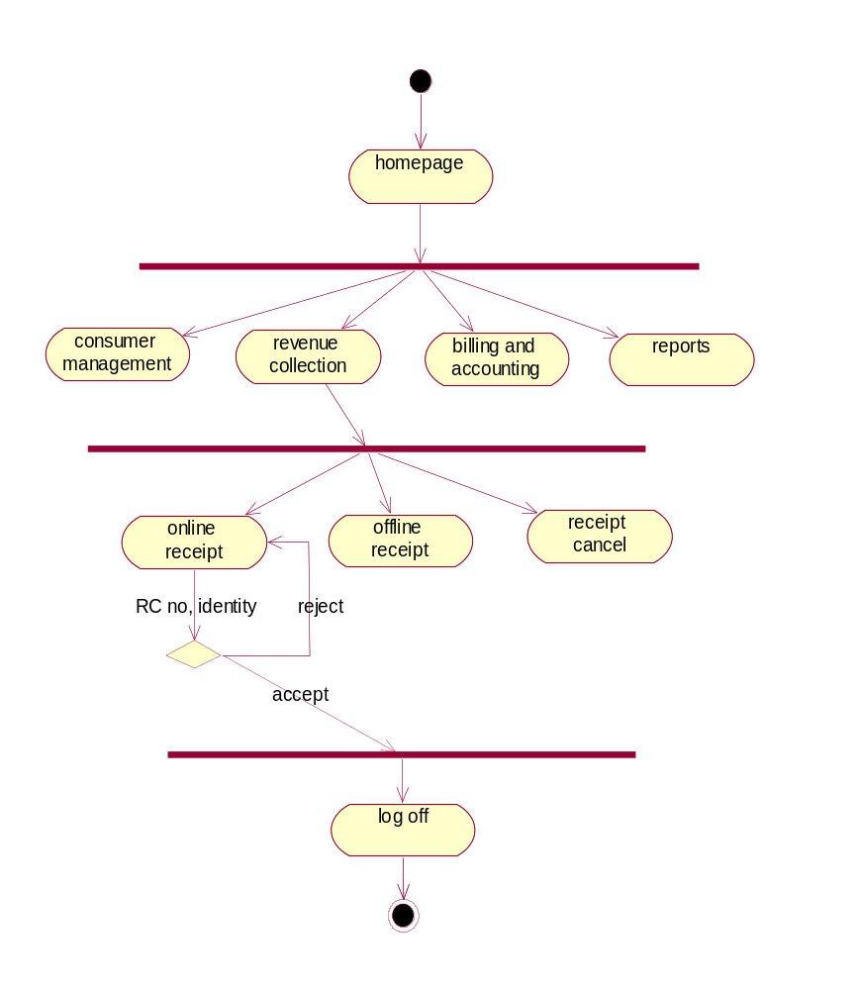
Fig 4.2.4.3: Activity Diagram

4.3.4.4 Activity Diagram
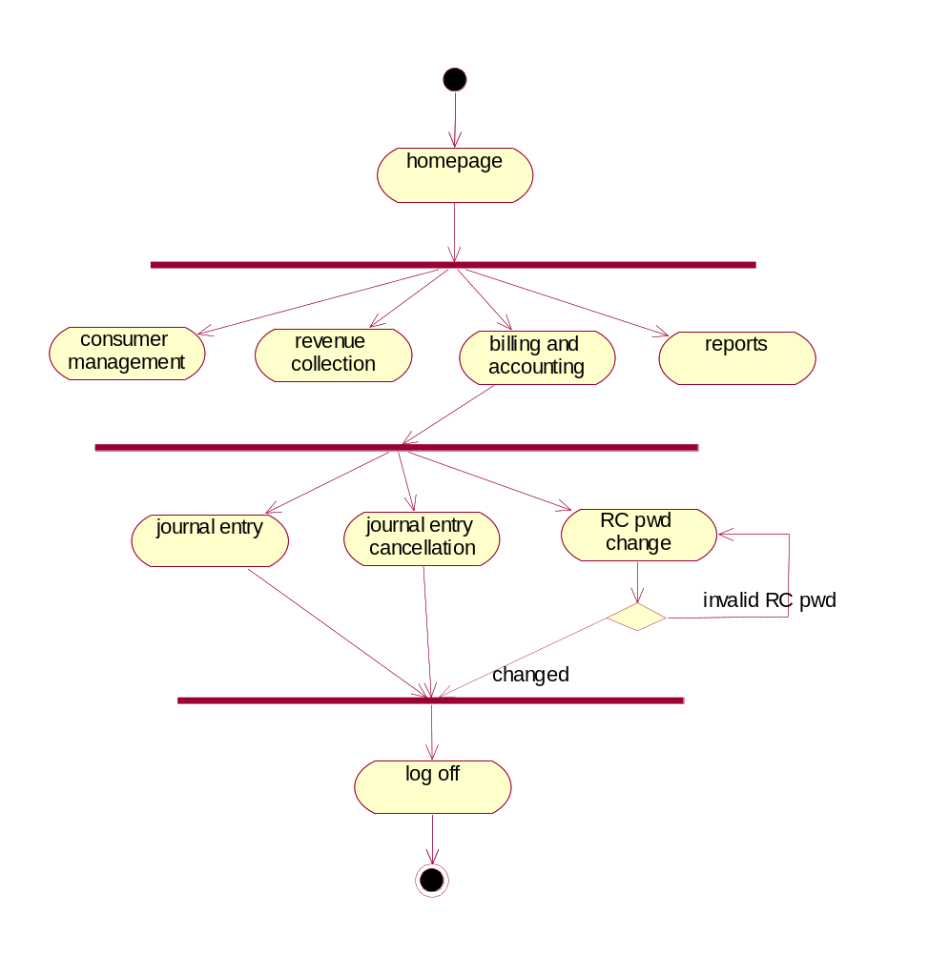
Fig 4.2.4.4: Activity Diagram

4.3.5 State Chart Diagrams
4.3.5.1 Login Module

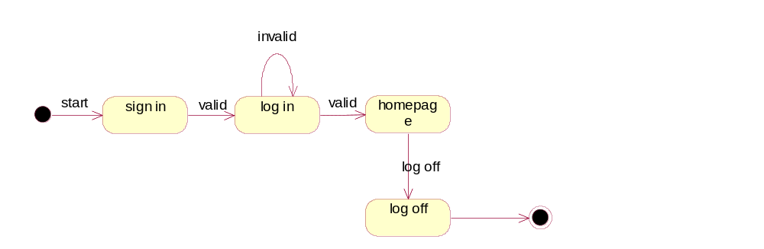

Fig 4.2.5.1 Login Module

4.3.5.2 Consumer Management Module

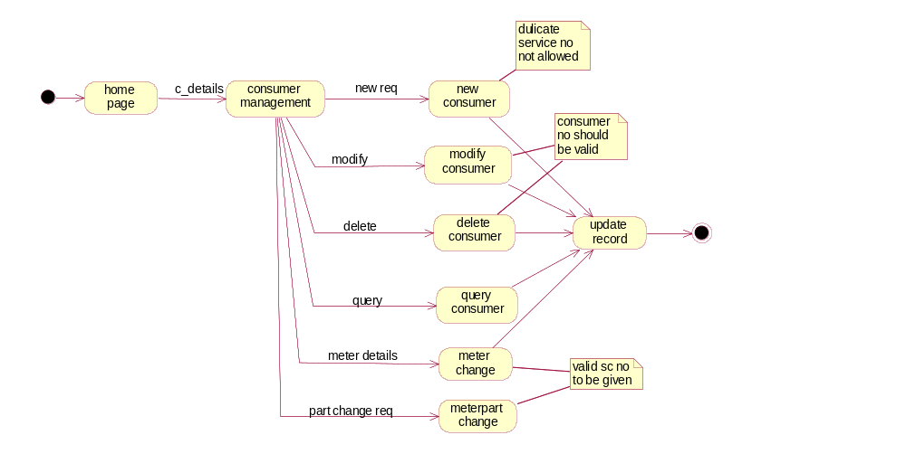

Fig 4.2.5.2 Consumer Management Module

4.3.5.3 Revenue Collection Module

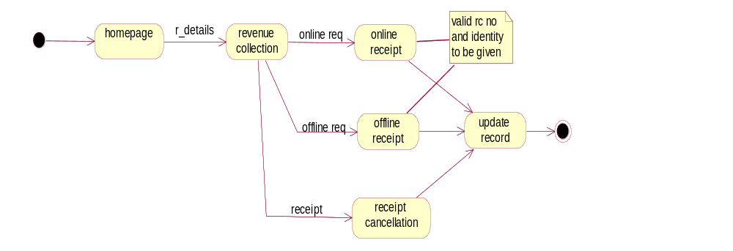

Fig 4.2.5.3 Revenue Collection Module

4.3.5.4 Billing & accounting Module

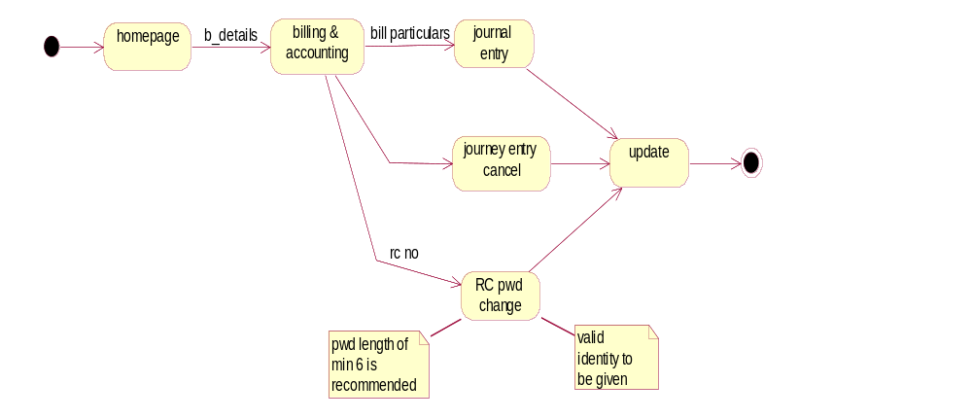

Fig 4.2.5.4 Billing & Accouting Module

4.3.5.5 Report Module

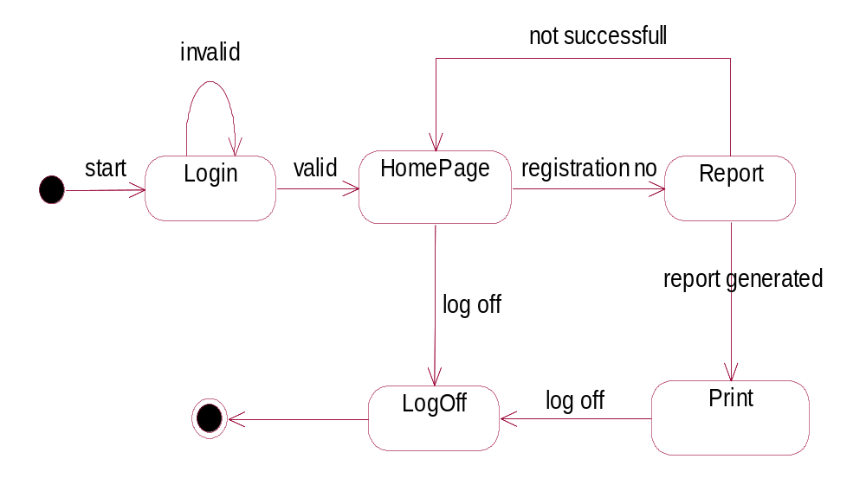
Fig 3.1.5.4 Report Module

4.4 Database Design
4.4.1 ER Diagrams
4.4.1.1 Homepage

Consumer
name
address
EBS
Reports
Revenue Collection
Billing & Accounting
manage
collect
issue
receipts
bill
reports
Bill no
Acc no
C no
service
Meter no

4.4.1.2 Consumer Management

New Consumer
name
address
Consumer mgmt
M_part change
Meter change
Modify consumer
New req
Meter reading
Meter no
SC no
modify
Part changeorts
Cons_no
Area
C no
Mtrl no
group
Delete consumer
Query consumer
delete
query
C no
New c_no
name
arrears

4.4.1.3 Revenue Collection

Online receipt
name
Bill no
Revenue collection
Offline receipt
Receipt cancel
online
receipt
receipt no
SC no
offline
SC no
name
RC no
identity
4.4.1.4 Billing & Accounting

Journal entry
name
acc no
Bill & accounting
RC pwd change
Cancel journal
journal
cancel
Acc no
Bill amt
Pwd change
RC no
RC name
4.4.2 Tables
1.CONS:

Column Name | Data Type(size) | Constraint
CTSCNO | CHAR(8) | NOT NULL
CTNAME | VARCHAR2(30)
CTADD1 | VARCHAR2(30)
CTADD2 | VARCHAR2(30)
CTADD3 | VARCHAR2(30)
CTADD4 | VARCHAR2(30)
CTPINCODE | NUMBER(6)
CTCAT | NUMBER(1)
CTSUBCAT | NUMBER(1)
CTDISCD | CHAR(3)
CTAREACD | VARCHAR2(6)
CTEROCD | NUMBER(3)
CTSUBDIVCD | CHAR(2)
CTSECCD | CHAR(2)
CTGROUP | CHAR(1)
CTLCNO | CHAR(2)
CTBILLMODE | NUMBER(1)
CTSUPCONDT | DATE
CTCNVTDT | DATE
CTSERVTYPE | CHAR(2)
CTCONLD | NUMBER(8,3)
CTCTRLD | NUMBER(8,3)
CTMRBNO | VARCHAR2(3)
CTMRBPAGE | NUMBER(3)
CTCONSTAT | NUMBER(1)
CTDATASTAT | CHAR(1)
CTCAPAVAIL | NUMBER(3,1)
CTCAPREQ | NUMBER(3,1)
CTAGRMTDT | DATE
CTCAPSURCHGPER | NUMBER(3,2)
CTAGRMTEXPDT | DATE
CTENTDT | DATE
CTBLSTDT | DATE
CTSDINTDT | DATE
CTSDTOTAMT | NUMBER(9,2)
CTSDREQ | NUMBER(11,2)
CTSDINTAMT | NUMBER(9,2)
CTSDONINTDT | NUMBER(11,2)
CTAMGAMT | NUMBER(9,2)
CTAMGYR | NUMBER(2)
CTAMGEXPR | DATE
CTMETSINSERV | NUMBER(1)
CTBLNOTPREPMN | NUMBER(2)
CTPENINTIND | NUMBER(1)
CTREBATEIND | NUMBER(1)
CTINSTMTIND | NUMBER(1)
CTBLISSUEID | NUMBER(1)
CTMTRCHGIND | NUMBER(1)
CTOTHERREV | NUMBER(9,2)
CTPHONE | NUMBER(8)
CTELDTYIND | NUMBER(1)
CTTYPE | CHAR(1)
CTTRCODE | VARCHAR2(8)
CTDEFAMT | NUMBER(9,2)
CTNEWSCNO | CHAR(11)
CTCYCLE | CHAR(2)
CTFEEDERCD | VARCHAR2(12)
CTDLISTFLG | NUMBER(3)
CTDLSTFLG | NUMBER(3)
CTAUTOPAY | VARCHAR2(20)
CTSDBALAMT | NUMBER(9,2)
CTACDSURCHG | NUMBER(9,2)

2. METER PART

Column Name | Data Type(size) | Constraints
MPTSCNO | CHAR(8) | NOT NULL
MPTMSLNO | NUMBER(1)
M PTMTRNO | VARCHAR2(12)
MPTMTRPHASE | NUMBER(1)
MPTMTRMF | NUMBER(5,2)
MPTMTRDIGIT | NUMBER(1)
MPTMTRCAP | VARCHAR2(8)
MPTMTROPNRDG | NUMBER(6)
MPTMTRCLRDG | NUMBER(6)
MPTMTROPNRDGDT | DATE
MPTMTRCLRDGDT | DATE
MPTMTRPREVSTAT | CHAR(2)
MPTMTRCURRENTSTAT | CHAR(2)
MPTMTRCHNGDT | DATE
MPTMTRMAKE | VARCHAR2(10)
MPTMTRSEALNO | VARCHAR2(8)
MPTEXCEPDT | DATE

3. BILL

Column Name | Data Type(size) | Constraints
BTBLNO | VARCHAR2(7)
BTBLDT | DATE
BTDUEDT | DATE
BTDISCDT | DATE
BTBLMTH1 | DATE
BTBLMTH2 | DATE
BTENGCHG | NUMBER(9,2)
BTCAPSURCHG | NUMBER(8,2)
BTFIXCHG | NUMBER(7,2)
BTFUELCHG | NUMBER(8,2)
BTCUSTCHG | NUMBER(9,2)
BTADLCHG | NUMBER(9,2)
BTOTHRCHG | NUMBER(9,2)
BTARRAMT | NUMBER(9,2)
BTADLARRAMT | NUMBER(9,2)
BTADLCHGARR | NUMBER(9,2)
BTADJAMT | NUMBER(9,2)
BTCURBAL | NUMBER(9,2)
BTOLDCURBAL | NUMBER(9,2)
BTPENINT | NUMBER(9,2)
BTINSTALAMT | NUMBER(9,2)
BTREBATEAMT | NUMBER(9,2)
BTROUNDAMT | NUMBER(9,2)
BTBLDUNITS | NUMBER(6)
BTELDTY | NUMBER(9,2)
BTELDTYARR | NUMBER(9,2)
BTELDTYINT | NUMBER(9,2)
BTELDTYINTARR | NUMBER(9,2)
BTEDADJAMT | NUMBER(9,2)
BTAMTPAID | NUMBER(9,2)
BTDEFFEE | NUMBER(9,2)
BTDEFARR | NUMBER(9,2)
BTCONCESS | NUMBER(9,2)
BTAPRARR | NUMBER(9,2)
BTARRCURR | NUMBER(9,2)
BTAPRARR1 | NUMBER(9,2)
BTARRCURR1 | NUMBER(9,2)
BTSUBSIDYAMT | NUMBER(8,2)
BTACDSURCHG | NUMBER(8,2)
BTSCNO | CHAR(8) | NOT NULL

4.PAYMENT

Column Name | Data Type(size) | Constraints
PTSCNO | CHAR(8) | NOT NULL
PTBCRNO | CHAR(8)
PTPRNO | NUMBER(10)
PTPRDT | DATE
PTRCCD | CHAR(2)
PTCOUNTER | NUMBER(3)
PTONOROFF | CHAR(1)
PTPAYMETH | CHAR(1)
PTCHKNO | CHAR(7)
PTCHKDT | DATE
PTBNKCD | CHAR(3)
PTBLAMT | NUMBER(9,2)
PTMISAMT | NUMBER(9,2)
PTRECONCHG | NUMBER(5,2)
PTCANCELID | CHAR(1)
PTBRNNAME | VARCHAR2(40)
PTMISAMTCD | CHAR(2)
PTELDTY | NUMBER(9,2)
PTELDTYINT | NUMBER(9,2)
PTADLAMT | NUMBER(9,2)
PTDEFAMT | NUMBER(9,2)
PTTOTARR | NUMBER(11,2)
PTTOTCUR | NUMBER(11,2)

5.RCNAMES

Column Name | Data Type(size) | Constraints
RCCODE | CHAR(2) | NOT NULL
RCINUSE | NUMBER(1)
RCSLNO | NUMBER(4)
RCPASS | VARCHAR2(8)
RCNAME | VARCHAR2(30)
RCTRY | NUMBER(1)
RCMAXDATE | DATE

6.ERO

Column Name | Data Type(size) | Constraints
EROCODE | NUMBER(3)
ERONAME | VARCHAR2(30)
EROUSER | VARCHAR2(20)
EROTYPE | NUMBER(1)

7.SECTION

Column Name | Data Type(size) | Constraints
SECCODE | CHAR(2)
SECNAME | VARCHAR2(30)

8.SUB DIV

Column Name | Data Type(size) | Constraints
SDCODE | CHAR(2)
SDNAME | VARCHAR2(30)

9.AREA

Column Name | Data Type(size) | Constraints
AREACODE | VARCHAR2(6) | NOT NULL
AREANAME | VARCHAR2(30)

10.AREA NAME

Column Name | Data Type(size) | Constraints
AREACODE | VARCHAR2(6) | NOT NULL
AREANAME | VARCHAR2(30)
AREAMR | VARCHAR2(20)
AREALI | VARCHAR2(20)
PVTMR | VARCHAR2(20)
11.BANK

Column Name | Data Type(size) | Constraints
BANKCODE | CHAR(2)
BANKDESC | VARCHAR2(35)

12.SUB CATEGORY

Column Name | Data Type(size) | Constraints
SCCAT | NUMBER(1)
SCSUBCAT | NUMBER(2)
SCDESC | VARCHAR2(45)
SCBILL_TYPE | NUMBER(1)
SCREAD_YN | NUMBER(1)
SCMAX_LOAD | NUMBER(8,3)
SCLOAD_HP_KW | VARCHAR2(10)
SCLOAD_UNITS | NUMBER(6)
SCREBATE_YN | NUMBER(1)
SCAMG_YN | NUMBER(1)
SCTARIFF_DT | DATE | NOT NULL
SCBILL_FACTOR | NUMBER(6,4)
SC_CONCESSION_UNITS | NUMBER(4)

CHAPTER 5: TESTING

5.1 SYSTEM TESTING

The development of Software System involves a series of production activities. There is a chance of errors to occur at any stage. Because of human inability to perform and communicate with perfection, a Quality Assurance Activity accompanies software development.

Software testing is a critical element of software quality assurance and represents the ultimate review of specification, design and code generation.

The increasing visibility of software as a system element and the costs associated with software failure are motivating forces for well planned, through testing.

For testing the system we followed the strategies given below.

Testing Techniques:

Different types of testing are

- Unit Testing
- Integrated Testing
- Black Box Testing
- Validation Testing
- User Acceptance Testing

During the implementation for the system each modules of the system was tested separately to uncover errors which its boundaries. User interface was used as a guide in this process.

The validations have been done for all the inputs using Java Script. For example to check whether the work allotted among the database correctly without exceeding the schemes which are not validated thoroughly and the internal database has to check the reflections in the database.

Boundary conditions Test:

Boundary conditions as in case of generating sequences were tested to ensure that the module operates properly at boundaries establish to limit or restrict processing.

Integration Test:

The objective of Integration Test is to take the until tested modules and build a program structure that has been defined in the design. We have done top down integration, which is constructing and testing small segments where errors are easier to isolate, and corrected. The integration process was performed in three steps:

- The main control was used as test driver.
- Test was conducted as each module was integrated.
- Regret icon testing (conducting all or some of the previous tests) to ensure that new errors have not been introduced.
Block Box Testing:

If focuses on functional requirements of the software. Block box testing attempts to find errors in the following categories.

Incorrect or missing function
Interface error
Errors in external device access
Performance error
Initialization and termination errors
The above testing was successfully carried out for the developed system.

Validation Testing:

At the culmination of integration testing, software is completely assembled as a package, interfacing errors have been uncovered and corrected, and a final series of software tests namely validation tests are performed. Validation succeeds when the software functions in the manner that can be easily accepted by the customer.

After validation test has been conducted, one of the possible condition is satisfied. The functions or performance characteristics confirmed to specifications are acceptable. The deviation form specifications are uncovered and a note of what is lacking is made. The developed system has been tested satisfactorily and its performed is also satisfactory. It is working efficiently.

User Acceptance Testing

User acceptance of a system is a key factor for the success of any system. The system under consideration was tested for user acceptance constantly, by keeping the users informed of the progress and incorporating changes suggested, at the development time itself.

Test Case Report

Here we specify all the test cases that are used for system testing. The different conditions that need to be tested along with the test case used for testing those conditions and the expected outputs are given. The goal is to test the different functional requirement document. Test cases have been selected for both valid and invalid inputs.

S.No | Test case | Condition | Expected Output
1 | Get Systems | Input Domain name | Print list of all system in current domains & response time
2 | Get User | Input Domain name | System id, user id, port no, domain name
3 | Get Processes details | Select process | Output the details of processes
4 | Get modules details | Select process & select thread opt | Details of modules
5 | Get thread details | Select process & select thread opt | Details of threads
6 | Stop the processes | System id, user id, password | Process close
7 | Stop the system | System id | System close

TESTING ANALYSIS

S.No | Testing object | Expected value | Simulated value | Explanation | Remarks
1 | User name & Password | AEIND  GUEST | AEIND  GUEST | Equal of expected and simulated values | Pass
2 | User name & Password | AEIND  GUEST | AEIND  GUEST | Unequal of expected and simulated value | Fail
3 | Change password | GUESS | GUEST  (Old password) | Equal of these two passwords | Pass
4 | Start time and end time | 11:03:05 | 11:03:05 | Equal of these times | Pass
5 | Start date and end date | 02/01/2006 | 02/01/2006 | Equal of these dates | Pass

CHAPTER 6: SCREENS AND REPORTS

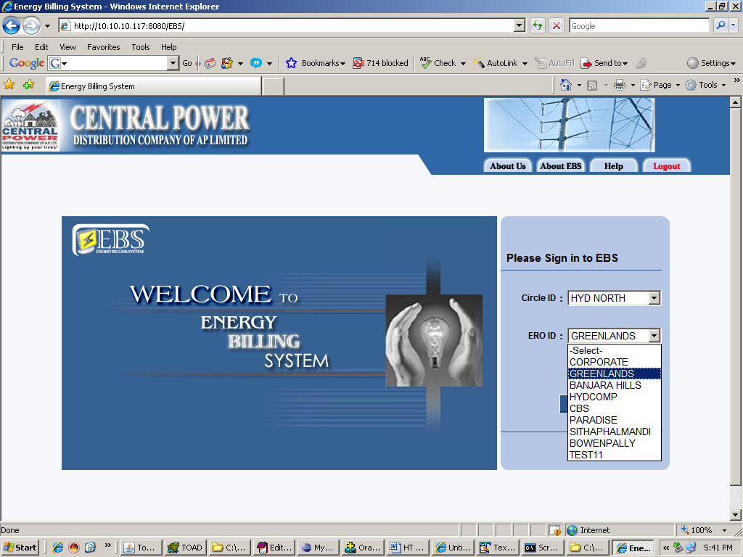

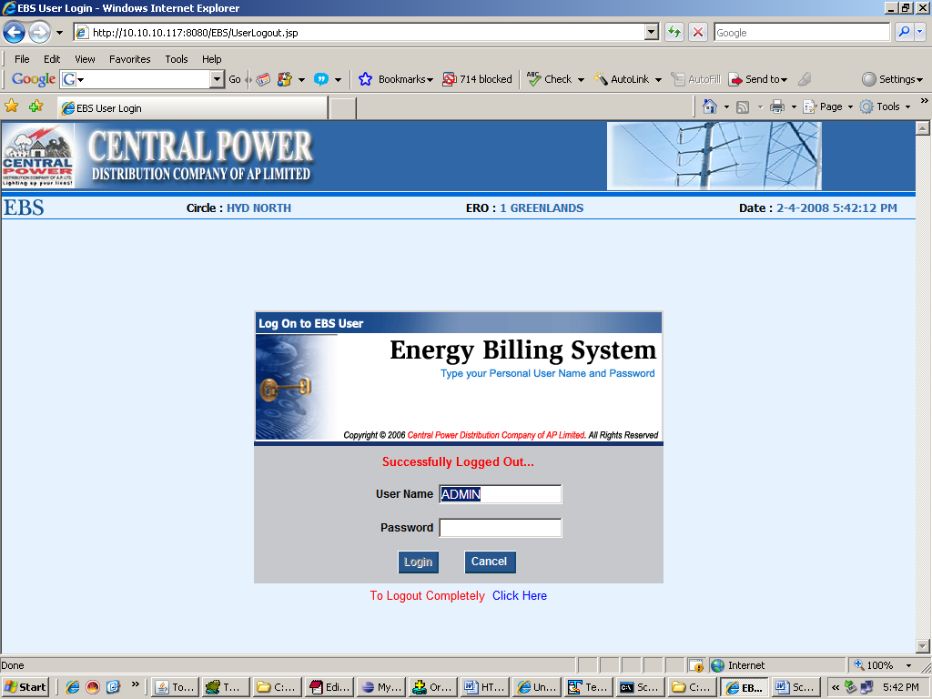
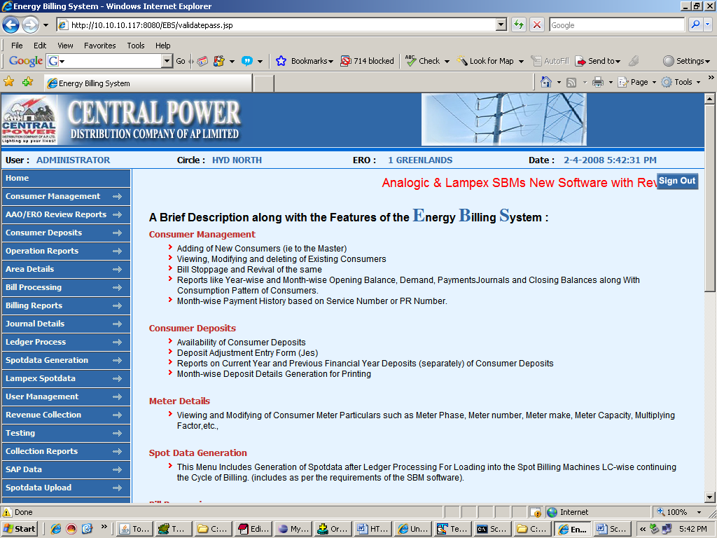
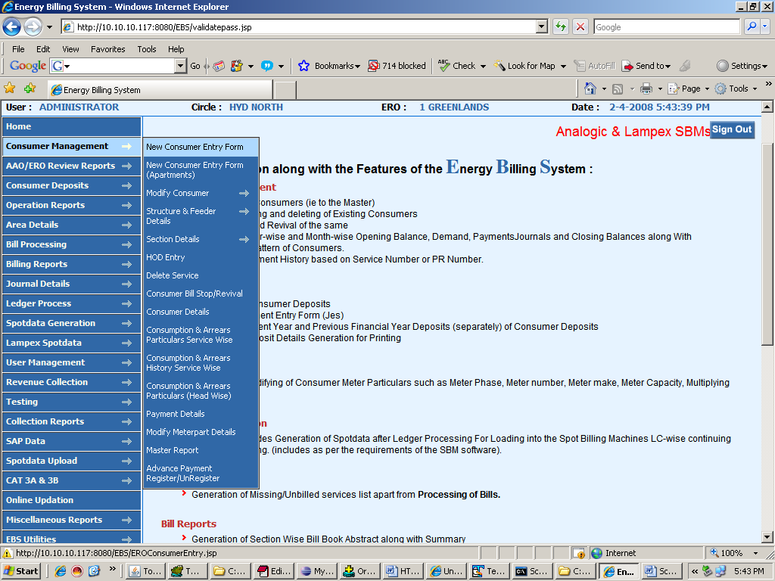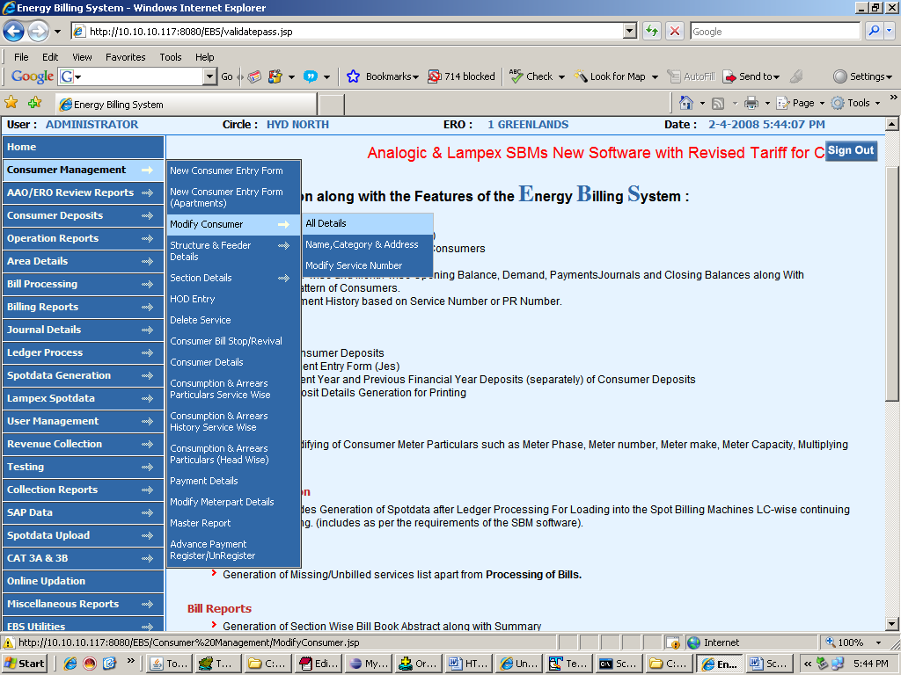New Consumer Entry
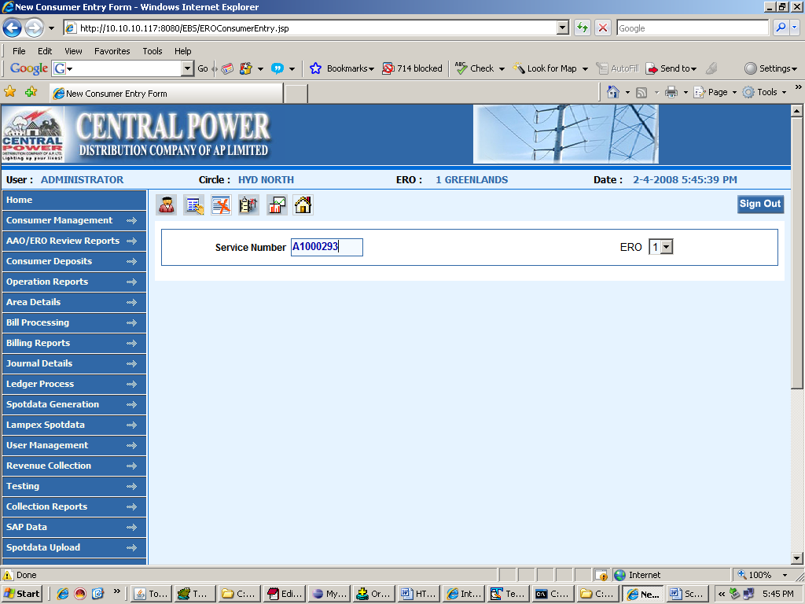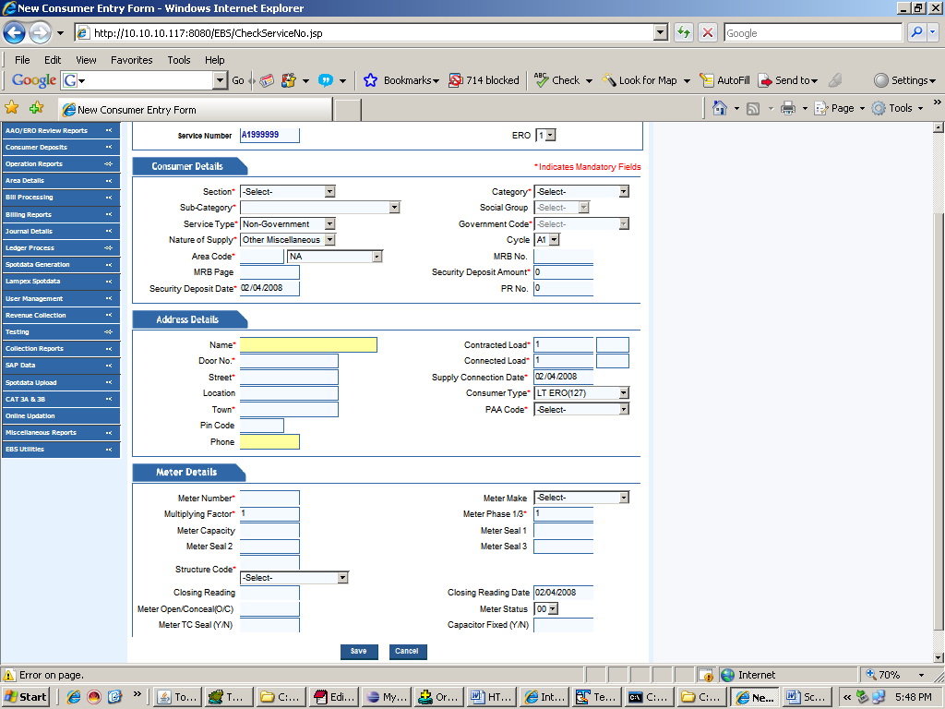

2. Modify consumer
a. all details

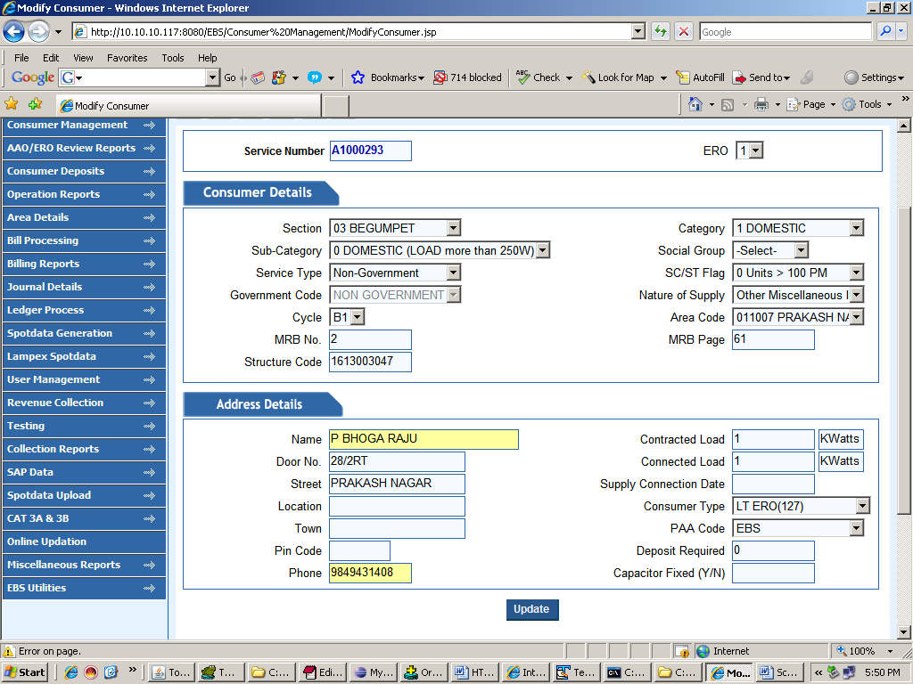

b. name and Category
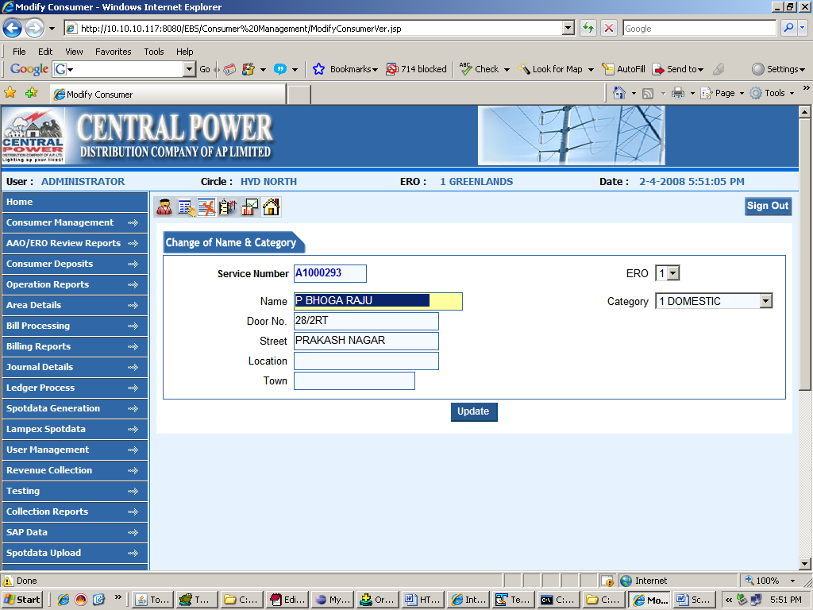

c. service change

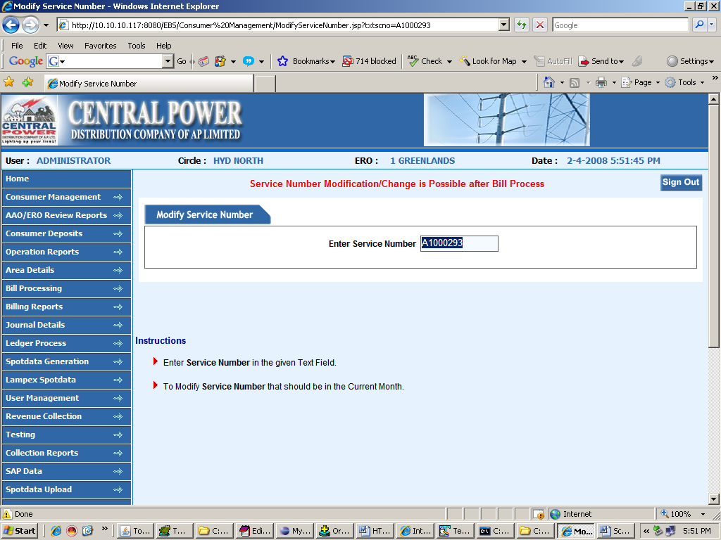

3. delete consumer

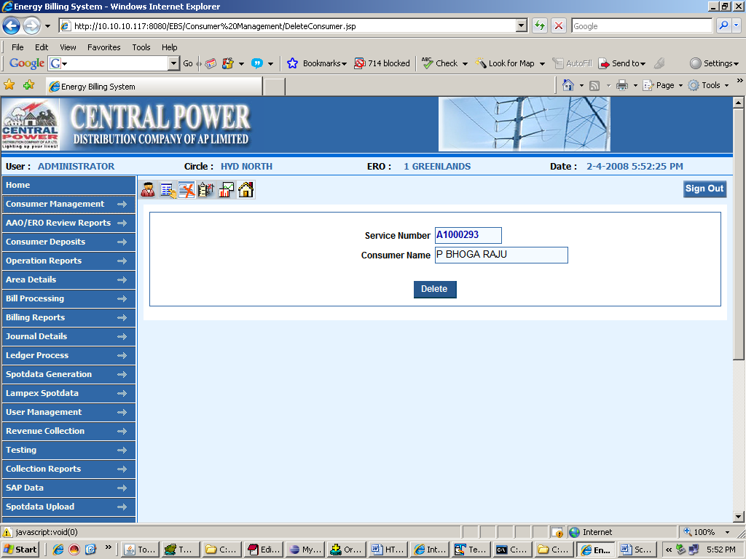

4. consumer details

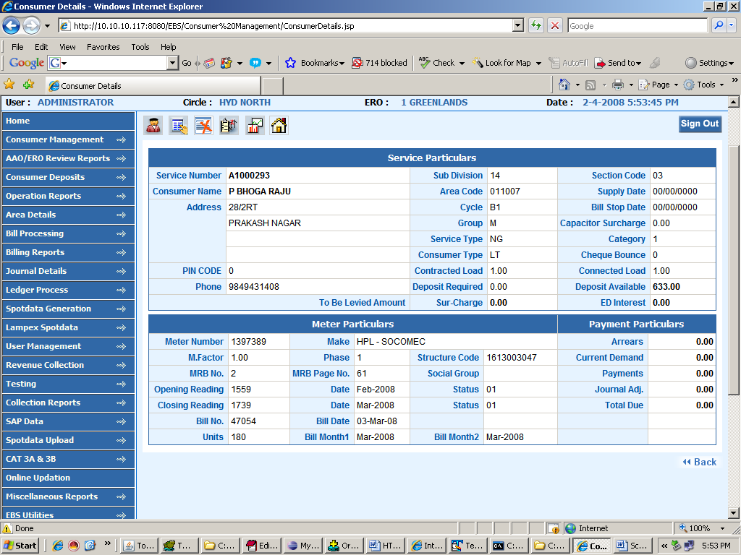

5. modify meter details

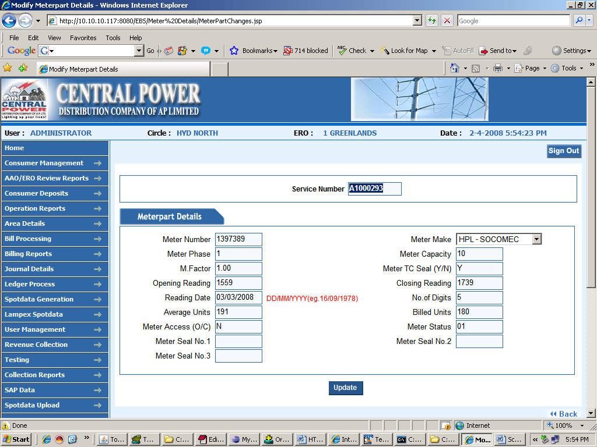

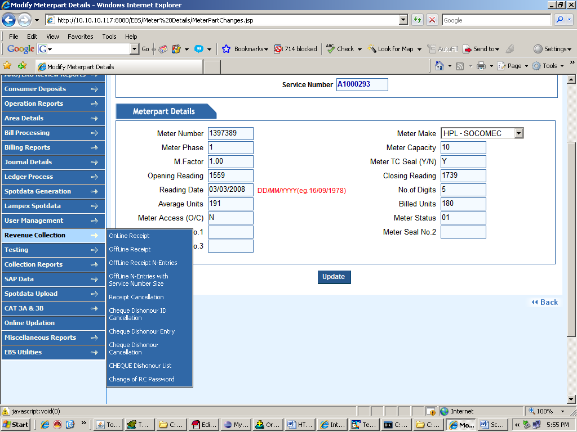

- online

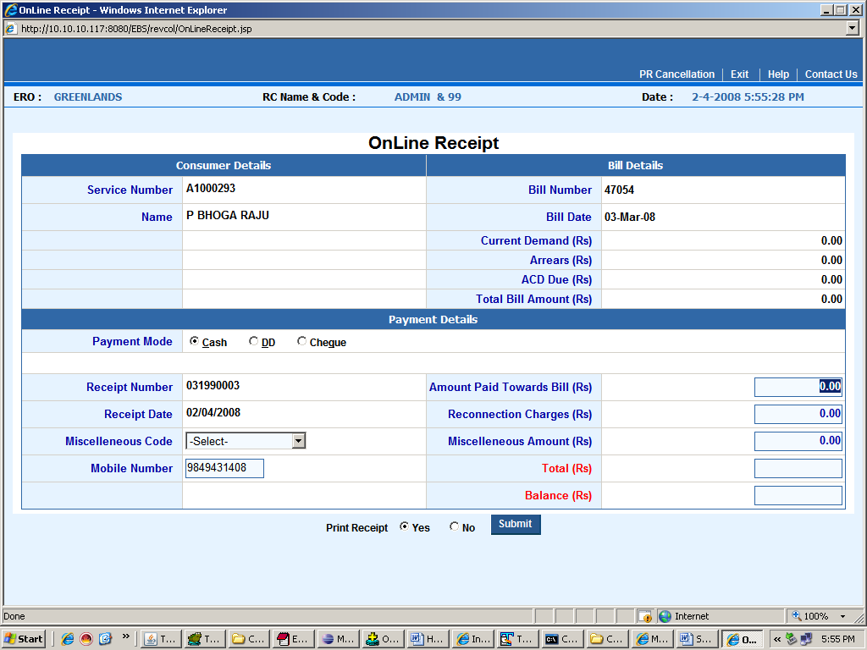

- offline

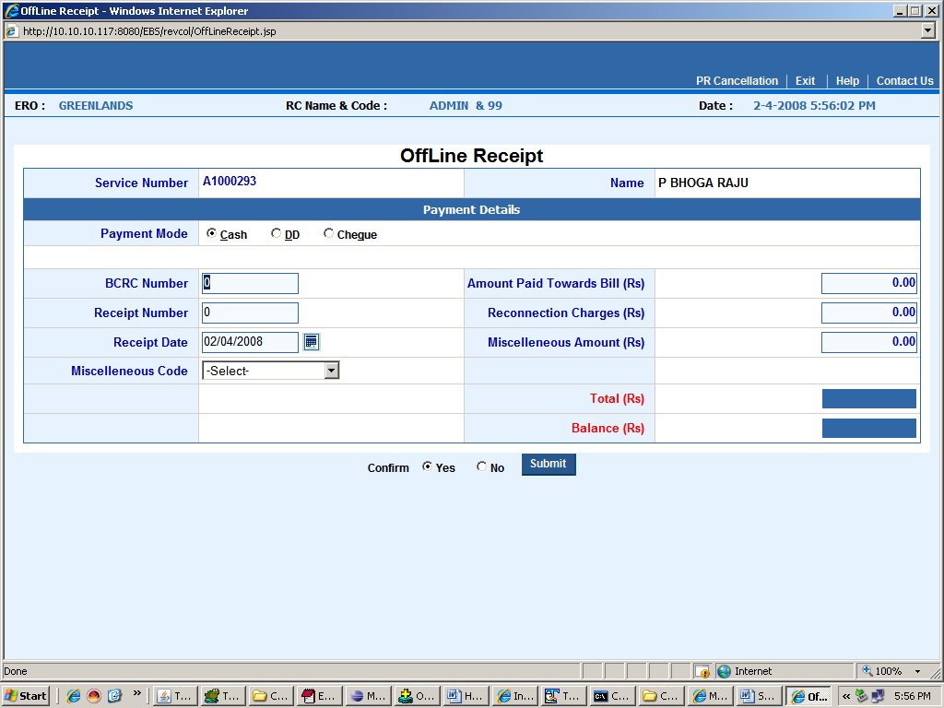

Offline N entry
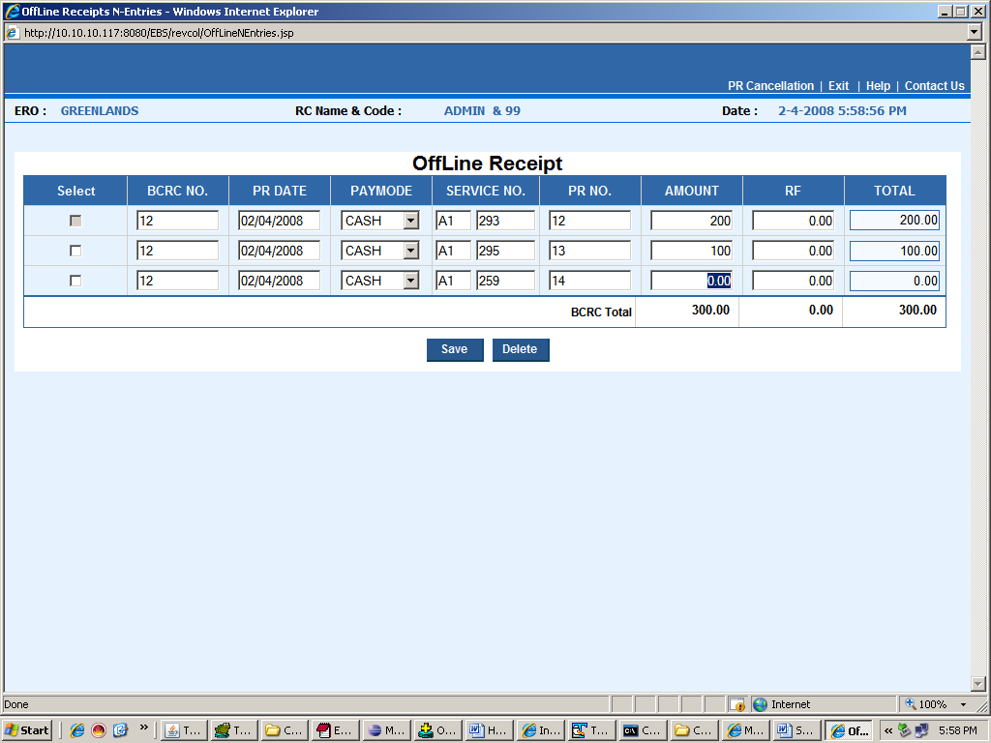

- receipt cancel

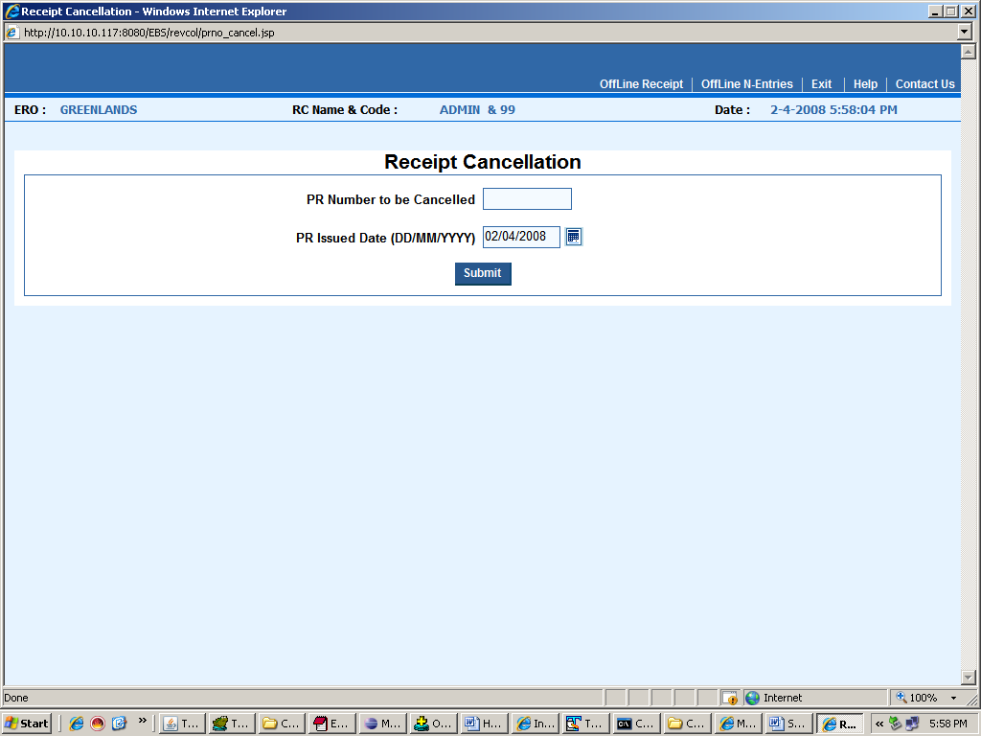

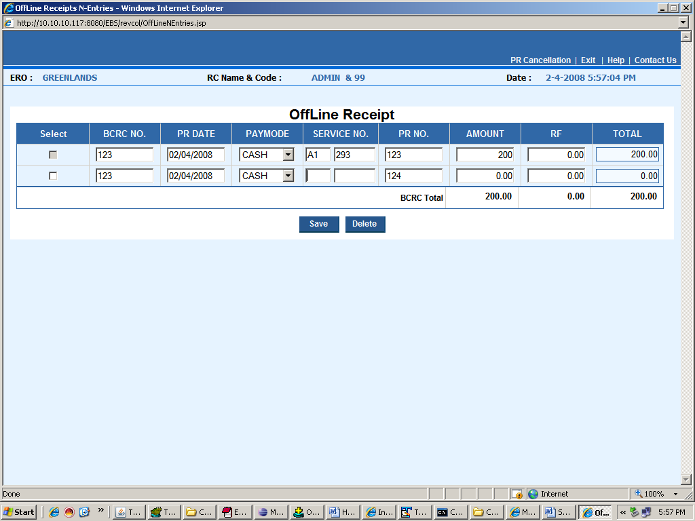

Rc password change

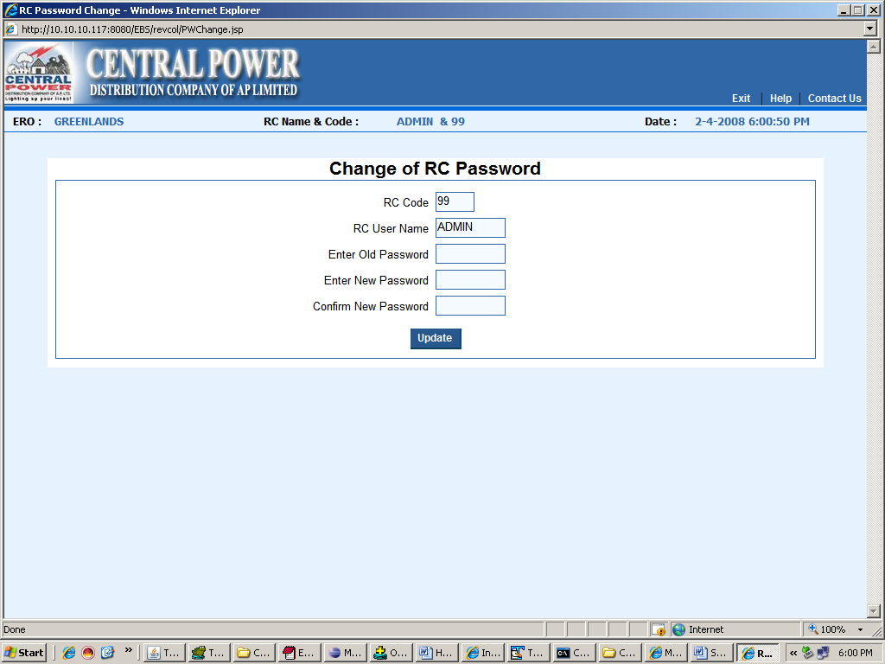

CHAPTER 7: CONCLUSION

We have been given the problem of Billing of Electricity Consumers in APCPDCL at APTRANSCO. Earlier the Billing process at ERO is manually calculated by using the database small tolls and small scale packages at their desktop. In our project “ENERGY BILLING SYSTEM” we have automated the entire billing system is Online and centralized with all offices which they have in the central power distribution company limited.

In Consumer Management, I have tracked all the information of the consumer and have given the privileged modifications, changes and deletion. This information can be easily made available to all the stores throughout the APCPDCL Offices through intranet/ Internet.

As a result of this automation, manual workload is reduced and data retrieval becomes easy. This project can be helpful for centralization of information regarding the stores of CEPDCL at APTRANSCO.

BIBLIOGRAPHY

- Database Management System
-C.J.Data

2.JAVA2 The complete Reference
-Patrick Naughton

3. Pure Java Script
-R.Allen Wyke & Charlton Ting

- Hyper Text Markup Language

- java.sun.com/products/jsp/

- www.javascript.com

- Jakarta.apache.org/tomcat

- java.sun.com/j2ee

- www.w3schools.com

